Reactive VFX Graph System

By Dale Grant

GitHub Repository: <https://github.com/DaleTGrant/ReactiveVFXGraphSystem>

# Project Goal

Visual effects in video games are a vital component in increasing the immersion of a player in a gaming experience and often provide the crucial final polish to a core feature of the gameplay. However, particle systems have the potential to be used in more applications than just visual polish and directly impact the game experience.

In the Unity Engine, there are two particle systems: the CPU-based Shuriken and the GPU-based VFX Graph systems. The Shuriken system is the default particle system used in the default render pipeline in Unity and supports thousands of particles per emitter whilst also allowing for direct interface with the physics system in Unity. As a result, the Shuriken system is ideal for the small emitters used in gun shots, running dust, and other localised feedback for the player.

On the other hand, the VFX graph of the Universal Render Pipeline in Unity utilises the parallelism of the GPU to simulate millions of particles simultaneously whilst only providing indirect physics interaction and limited script interaction. This makes the VFX graph system ideal for large-scale, high-complexity emitters that are often used for background details such as snow, sandstorms, petals in the wind, and many more. Despite the complexity of these VFX emitters, the potential of integrating the VFX system into the gameplay mechanics of games through features such as area effectors, variable binding, and skinned mesh rendering has yet to be fully explored.

In this project, I explore the strengths and limitations of the VFX graph system and utilise Vertex Animation Textures (VATs) to animate VFX graph systems that are based on animated skinned mesh renderers. These animated VFX systems combined with real-time feedback from collisions with the Shuriken CPU particle system to create a playable character comprised of VFX graph particles that respond to external stimulus.

Contents

Project Goal 1

Part 1: What is VFX Graph? 5

VFX Graph vs Shuriken Particle System 5

VFX Components 5

Context Nodes 5

Spawn Context 5

Initialize Context 5

Update Context 6

Output Context 6

Blackboard 6

Tricks for certain Effects 6

How to stop VFX from playing on awake 6

Collision With Primitive Colliders 7

GPU Events for interactive particle spawning 8

To make a Particle face along an axis 8

Point Caches for particles on meshes 8

Part 2: What are VATs? 11

Why VATs over traditional bone-based CPU animation? 11

Why VATs for this project? 11

How to create VATs? 11

Making VATs in Blender 11

Utilising VATs in VFX Graph 12

Complications of Blender VAT 13

Writing my own VAT generator script 13

Baking Meshfilter animation to VAT 13

Baking SkinnedMeshRenderer to VAT 15

Import settings for VAT 15

Using VATs in VFX Graph 17

VAT Reading Process 17

VAT UV Mapping Operator 18

Result of the VAT Generation Technique 19

Even further beyond: VAT shaders for particles in a VAT VFX system 19

Part 3: Force Feedback Goal 20

Version 1: Offset by a force and return via toggle 20

Exposed Parameters & Initial System State 20

Update Behaviour 21

Timer Control 21

Lerping Position and Velocity 21

Result 22

Version 2: Offset by sphere collision and lerp to original position via toggle 23

Result 23

Version 3: Offset by an external CPU particle collision and then lerp back to original position automatically upon zero velocity 25

The Main VFX Graph 25

System Initialisation 25

The Update Context 25

The Explode Subgraph 28

Particle Collision Script 28

The Explode and Reset Methods 29

A word about Timescales 29

Handling Particle Collision 30

Result 31

Version 4: Offset by multiple simultaneous external cpu particle collisions and then lerp back to original position automatically via averaging 32

Result 32

Version 5: Offset by multiple simultaneous external cpu particle collisions and then lerp back to original position automatically via individual consideration 34

Texture Generation and Texture Reset 34

Particle Collision 35

Explode/Reset 35

The VFX System 36

Individual Force Block Subgraph 37

Collision Texture Extractor 37

Result 38

Version 6: Combine Collision Effects with VAT animated VFX system 40

Result 40

7. Transitioning between VAT textures according to script 41

7a. Animation Transition via VFX Graph Toggle 41

Initialization 41

Update Context 41

Result 43

7b. Animation Transition via Script 43

VFX System 44

VFX Animation Transition Script Logic 44

Result 47

8. VFX system with movement via script 48

Initialization of the Movement Script 48

Input Setup 48

Update 49

Result 51

9. VFX system with movement connected to Animator 52

Result 53

10. Separation of Movement & VFX for World Scattering 54

Result 56

11. Animating colliders for more natural particle collisions and gameplay interactions 57

Creating A Blender Character 57

Animating the Character 58

Generating VAT for each animation 58

Syncing the VAT animations to the Animator 59

Finetuning the Colliders 60

Final Result 61

Potential future Improvements 62

1. Introduction To VFX Graph

# Part 1: What is VFX Graph?

* GPU particle system that processes millions of particles in parallel
* Can be used to perform complex math that is separate from the Unity Physics system and universal forces.
* Can be controlled via scripts, although difficult

# VFX Graph vs Shuriken Particle System

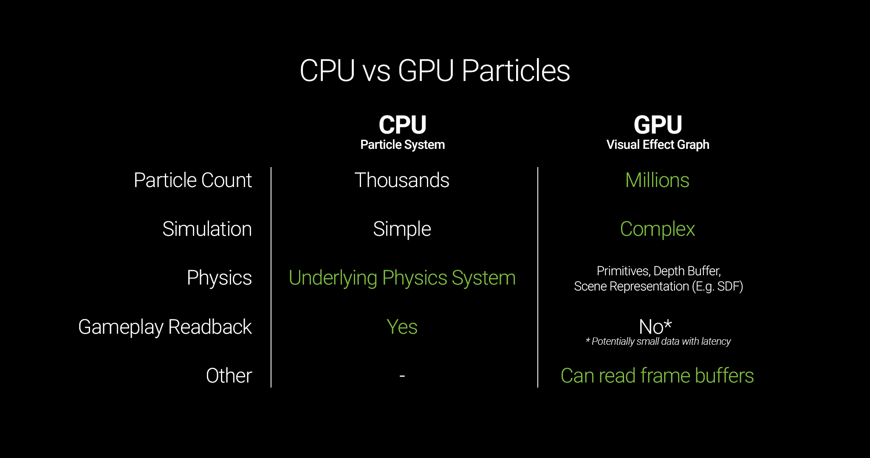

Fig. 1.1. Comparison of CPU Particle System and GPU Particle System

# VFX Components

## Context Nodes

### Spawn Context

Allows for the selection of the way the particles are to be spawned:

* At a constant rate
* In Bursts (periodically or once-off)
* Custom Rate
  + Via Spawn Events connected to an attribute
  + Custom methods (looping with a delay, over distance, etc)

Also worth noting, in the inspector for this node, you can set the loop time, number of loops, and time delay associated around a loop’s start/end

### Initialize Context

Set the initial stat of parameters of the particle on spawn, such as:

* Lifetime
* Position
* Rotation
* Velocity
* Size
* Color

### Update Context

Effects that apply on the particles over time, such as:

* Color
* Size
* Position
* Forces
* Velocity
* Rotation
* Mass
* Collision checking
* Destroy

### Output Context

Rendering settings of the particles, such as:

* Primitive Shapes (Triangles, Octogons, Quads)
* Mesh
* Distortion Mesh (HDRP)
* Orientation
* Screen space
* Main Texture

## Blackboard

Stores references to the variables used throughout the VFX graph. Use to store a value that you want to access in multiple locations or expose to the editor. These values can also be set via C# scripts as well via: vfxEffect.SetVector3(“StartPosition”, transform.position)

# Tricks for certain Effects

## How to stop VFX from playing on awake

Oddly, there isn’t a play on awake toggle for visual effects. So the best way is to override the Initial Event Name for the visual effect in the inspector to “”.

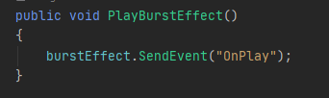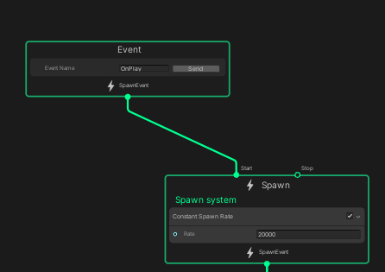

Fig. 1.2. Preventing a VFX system from playing on awake

Then in script, when you want it to play, with the name corresponding to the name of the event you have connected to the start node.

## Collision With Primitive Colliders

Sometimes you want particles to collide with an object. VFX graph only natively supports a small number of primitive collider types:

* Sphere
* AABox
* Plane
* Cone
* Cylinder
* Signed Distance Field
* Depth Buffer

The properties of these colliders can be set externally via exposed properties as shown below:

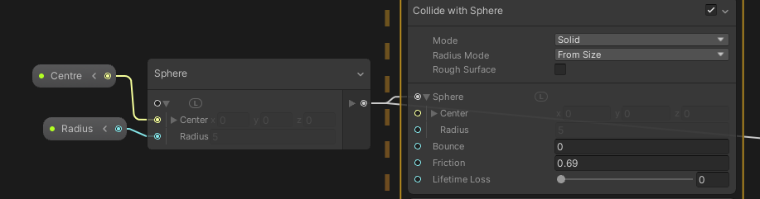

Fig. 1.3. Collision with sphere defined via script or VFX Property Binder

Note that in the script, it is important to note the acting space of the particle system and the object you want to represent in the scene. If particle system is local, then some conversion will be required. A trick I found was to place a script on the object you want to collide with that has a list of all visual effect that you want to update and then update the values of the collider via the script.

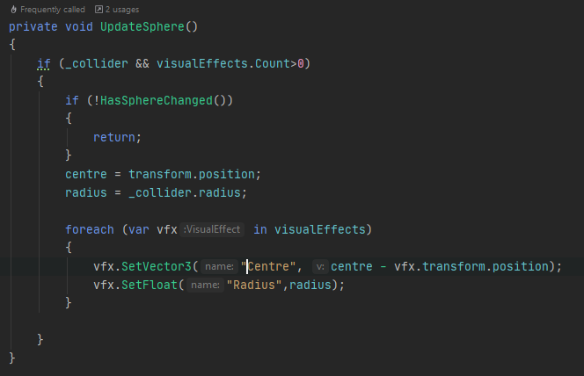

Fig. 1.4. Setting exposed parameters of a number of Visual Effects systems

## GPU Events for interactive particle spawning

After a particle collides, it can bounce, stick to it, and/or expire (set by lifetime Loss). In the case a particle dies, you can send a GPU event that can be used to initialize new particles in the system via the Trigger Event on Die Block. Additional GPU events include Trigger Always and Trigger Event Distance.

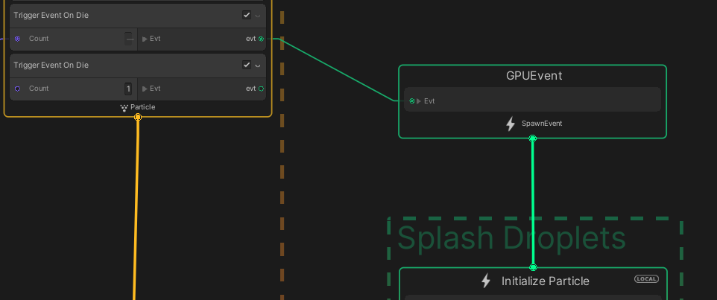

Fig. 1.5. Utilising GPU events to spawn additional particles

## To make a Particle face along an axis

To make a Quad particle to orient along an axis (say the y-axis) use the Orient:Advanced block and set it to Axes XZ.

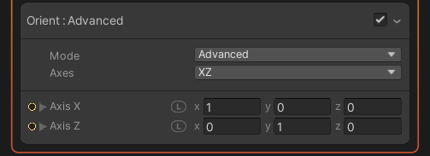

Fig. 1.6. Orienting Particles to an axis

## Point Caches for particles on meshes

If you want particles to spawn at, move to, or have knowledge of a mesh, it first needs to be converted into a point cache file.

Point cache files bundles a point count + one or more AttributeMaps, each baked into a texture. Each AttributeMap maps an attribute (i.e. position) to a point (vertex) and which can be utilised by a number of blocks in VFX Graph.

Methods of generating a point cache include:

* The Point Cache Bake Tool that is built into Unity
* Using the Houdini pCache Exporter
* Making your own exporter

So far, I have used the Built-in Point Cache Bake Tool, which allows for Meshes and Textures to be baked into a pCache file.

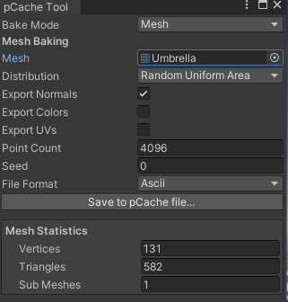

Fig. 1.7. Unity’s built-in Point Cache Bake Tool

The attribute maps that this method gives access to are:

* Position
* Normal
* Color
* UV

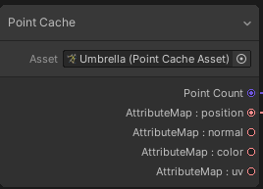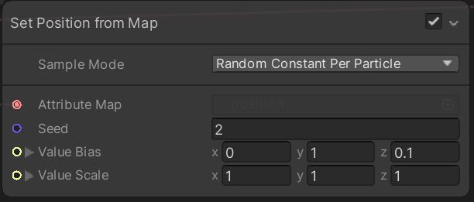

Fig. 1.8. Setting values from the maps stored in a Point Cache

The problem with this tool is that it does not allow for prebaked animations which makes it good for static meshes, but not for characters that are animated.

That said, even if prebaked animations are working, it may be difficult to animate them for use in a character. This may be remedied once Unity has developed the skinned mesh sample functionality on their roadmap.

For now though, either I look into making my own point caches either via Houdini or make my own exporter as it may be possible to do animations via a Texture3D in a point cache for say position with dimensions [index, position, time].

I had a look into the way Keijiro did his version of this, and it seems Unity does things with the Timeline feature and Compute Shaders, which is currently quite hard to reverse engineer atm due to the complexity. So, I decided to investigate Vertex Animation Textures and the avenues they provide.

2. Vertex Animation Textures

# Part 2: What are VATs?

VATs are a 2D texture where each pixel represents a specific vertex on a specific frame of animation. Typically, the x-axis of the VAT is the vertex index of the mesh/point, y-axis is the frame count of the animation, and the color of the pixel is the Vector3 of the vertex attribute (position, normal, color, velocity, etc). These 2D textures can be read by VFX graph and shader graph and utilised in a range of ways such as mesh animation to particle simulation caching.

GDC Talk on VATs (+ bone VATs): <https://www.youtube.com/watch?v=EUTE1SoOGrk>

# Why VATs over traditional bone-based CPU animation?

VATs allow for GPU-side simulation separate from the GPU. This allows for efficient, parallel animation of meshes, particles, bones, and more. This is especially important for games with crowds as you have many actors performing very similar animations in high numbers.

# Why VATs for this project?

The purpose of investigating VAT for this project is to find a way to have particles follow and animating mesh in Unity VFX graph. Once these particles know how the mesh vertices are moving throughout the animation, perturbations to these particles can allow for interesting player-world feedback. For example, imagine if the player was shot, you could have the particles near the location be scattered by a force, with some of them being destroyed, then when the remaining particles return, the player particle system will be incomplete, demonstrating residual damage.

As VFX graph does not natively allow for sampling skinned mesh renderers in its current state (and the solution by Keijiro is way above my current knowledge base), I came upon the concept of baking animations into textures for the VFX to read and act upon.

# How to create VATs?

The recommended way by Unity in order to create VATs is the use the VFX Toolbox extension for Unity/Houdini, where an animation in Houdini is converted into a VAT output via the SideFX VAT output node. The problem with this method is that it requires a non-apprentice version of the Houdini software as that version does not allow for fbx files to be generated without watermark, thereby preventing the mesh creation process.

Other similar software such as 3DMax and Maya have exorbitant costs, however, Blender may have a method that allows for me to create the types of VATs I desire.

VAT Theory: [https://medium.com/tech-at-wildlife-studios/texture-animation-techniques-1daecb316657#](https://medium.com/tech-at-wildlife-studios/texture-animation-techniques-1daecb316657)

Making VAT in Blender for Unreal: <https://www.youtube.com/watch?v=6aUlPlsCmvc>

Making VAT in Blender for Godot (+ theory): <https://www.youtube.com/watch?v=NQ5Dllbxbz4>

# Making VATs in Blender

1. Make the mesh and animation that you want to export the VAT for
   1. In my case, just a basic Suzanne mesh with some rotation
2. Install the Unreal Tools add-on for blender (Vertex Animaiton)
3. Open the Unreal Tools tab (ctr+n), select frame range, and process the animated mesh.
   1. Produces an export_mesh file that is required for Unreal import, but not needed for our case
4. Under the UV editing tab, some UVs offset.001 and normal.001 were produced. These store the Offset position (difference from vertex origin position) and normal for each vertex per frame. The texture is [v x f] in dimensions, where v is the vertex count and f is the number of frames of the animation. As such, each frame is a row and each vertex over time is a column with the color being the value (note: shifted from [-1,1] range to [0,1] for color storage).

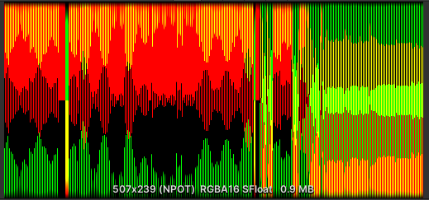

Fig. 2.1. Example of a VAT for 507 vertices and 239 frames.

Note that as rotation is around the z-axis, the vertices have no z-position displacement, and therefore the blue channel is black.

## Utilising VATs in VFX Graph

Just copy the textures into your desired asset folder.

The below are the settings for position VAT in Unreal, so we want to do something similar in Unity.

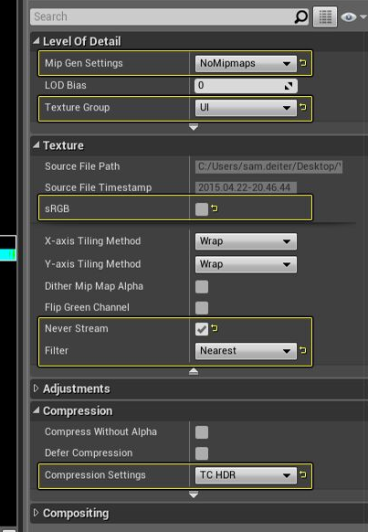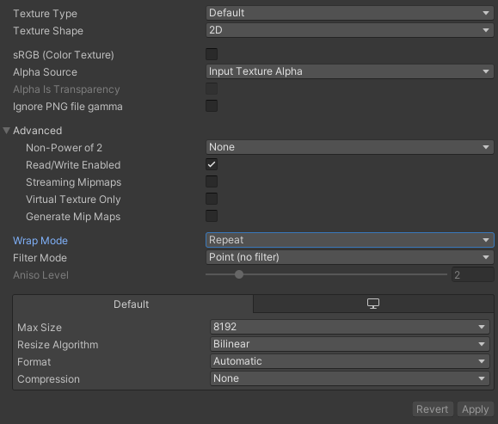

Fig. 2.2. Settings to import VATs into Unreal and Unity respectively

## Complications of Blender VAT

Since Blender is writing the VATs, I have less control and understanding over the information regarding the texture. This resulted in debugging the system to be more problematic as I was unsure if it was that the VAT was incorrect or my extraction of the information into my VFX graph was flawed, or both. As such, I deemed it better to take a step back and write the VAT writing process myself in Unity for a given mesh (static/Meshfilter or skinned mesh renderer).

# Writing my own VAT generator script

For this script, I decided to do the simplest VAT, where the width of the texture is the number of vertices and the height is the number of frames, with the color being the position.

For this script to work, the following needs to be supplied:

* The gameobject with a child game object that has the mesh and renderer components
* The animation clip that will animate the mesh/gameobject
* The number of frames in the animation
* The space of the position values (local or world)
* The directory to save the texture to

The script works by first determining if the renderer is a meshfilter or a skinnedmeshrenderer and then calls the appropriate method.

## Baking Meshfilter animation to VAT

First, the texture needs to be created. In the Meshfilter method, the width is the vertex count of the sharedmesh of the meshfilter and the height is the supplied frame count. Then the texture is created with 8bit color and sRGB color.



Fig. 2.3. Initialising the texture

A new mesh is defined to be written to and then we loop through the frames to being the pixel writing process. First, we normalise the current frame number by the frame count-1 so that we sample the animation correctly, which updates the animation to the frame we want to sample the mesh at. Then the current shared mesh is stored in our previously defined mesh variable.

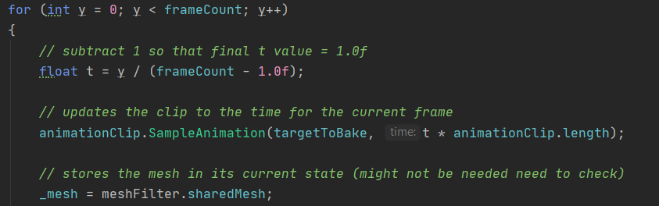

Fig. 2.4. Looping through frames in order to sample the mesh at each frame

Now that we have the mesh for the desired frame, we need to loop through each vertex, get its position, and ensure that it’s in the correct local frame and space before writing it to the pixel.

Sampling the vertex position is simple via the mesh.vertices property, however, this value is the position according to the mesh co-ordinates and not the local space of the gameobject that has the animation being applied to it. That means if a cube moves back and forth, the position of the transform is what is moving, and not the mesh itself according to its own frame of reference (FOR). As such, we need to convert the mesh FOR to that of its gameobject. This is achieved via a conversion matrix via Maxtrix4x4.TRS(position, rotation, scale) which produces a conversion matrix that can be used to convert a position to the FOR of a set of given position, rotation, and scale via matrix multiplication.

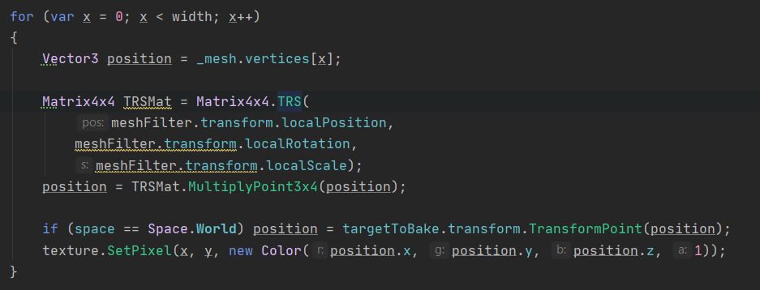

Fig. 2.5.Reading the mesh vertices and transforming them to game object coordinates

Then we see if we want the position in local/world space, and write to the pixel in our texture. Note that the raw position values are being stored into the color channels. Surprisingly, this does cause any issues as I was expecting the need to convert it into a 0-1 range with a scale factor.

Once all of the pixel have been set, we call texture.Apply() and start the texture saving process, which is involves requires the texture to be encoded to EXR format, determine file name, write all bytes to a file, refresh Unity database, and delete the texture to free up memory.

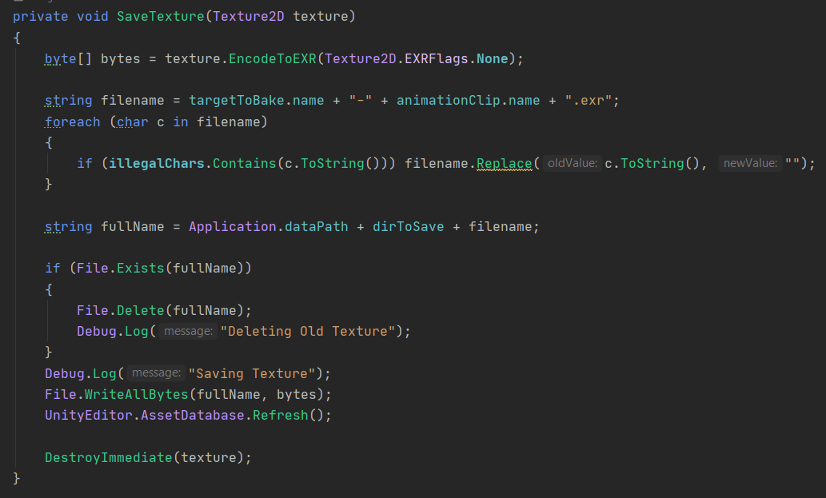

Fig. 2.6. Saving the Vertex Animation Texture

## Baking SkinnedMeshRenderer to VAT

The process is the same for the skinned mesh renderer with the main difference is rather than setting the stored mesh to the sharedmesh directly, you need to call the BakeMesh method of the skinned mesh renderer which creates a snapshot of the skinned mesh renderer and outputs it as a mesh.



Fig. 2.7. Adjusting for a SkinnedMeshRenderer

# Import settings for VAT

After some experimentation and reading about how VATs are utilised in shaders, I have optimized the import settings for VAT in Unity.

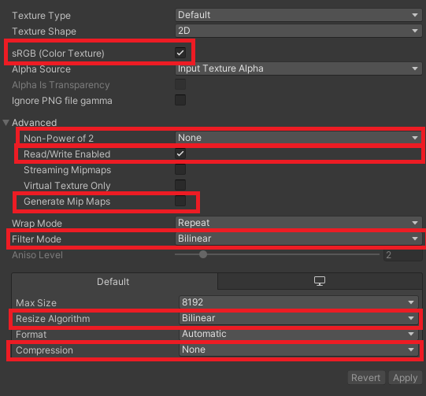

Fig. 2.8. Import settings for my VATGeneration method

1. *sRGB***: True** : This is important as it matches what we the texture to be in the VAT generator script
2. *Power of 2*: **None** : As we have an exact number of vertices/frames, we do not want to round to the nearest power of 2
3. *Read/Write*: **True** : As we are going to load and access this texture, we need this to be enabled
4. *Generate Mip Maps*: **off** : Just to prevent any accidental down resolution, turn this off
5. *Filter Mode & Resize:* **Bilinear** : This makes the animation smoother by blurring the pixel edges, basically interpolating between the pixel values, giving us free tween frames
6. *Compression*: **None**: We want exact color values, so turn off compression. If this is on at all, it remaps to 0 – 1 for all color channels.

# Using VATs in VFX Graph

To utilise the position data we have stored in the VAT, we need to do the following:

1. Spawn enough particles to place at each vertex (particles have infinite lifetime)

Then The Actual VAT reading process

1. Convert the current frame and particle id to UV co-ordinates [0-1]
2. Samples the VAT texture based on those co-ordinates
3. Set the position of the particle to the sampled color

STEP 1: This was easily achieved by having an exposed Vector2 that has the texture dimensions, and then set the single burst count to the x-component.

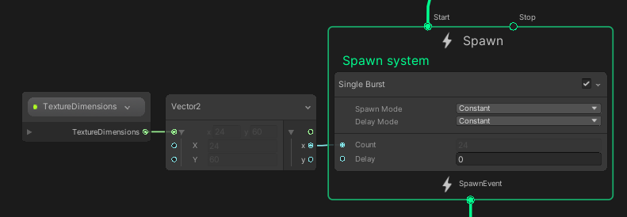

Fig. 2.9. Setting particle count to the vertex count

## VAT Reading Process

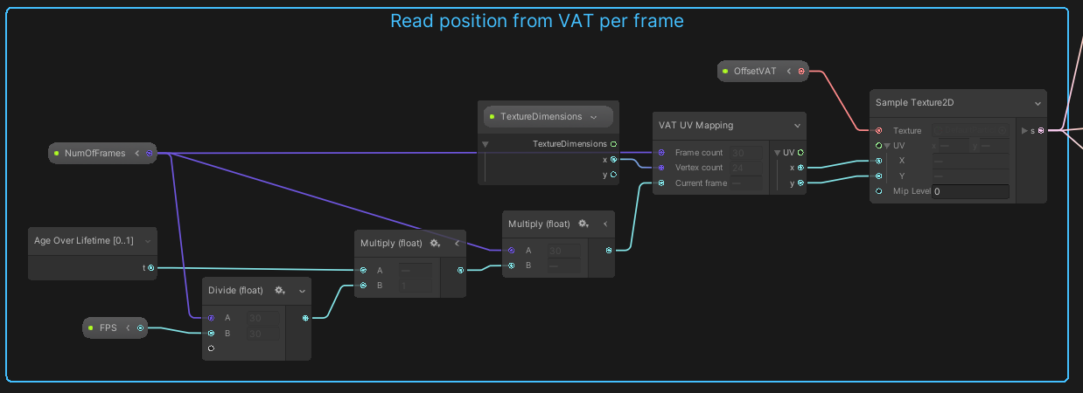

Fig. 2.10. Reading a position from a VAT for a given number of frames over time

The left hand side converts time to the current frame of the animation.

The current frame, number of frames, and the vertex count are passed into the VAT UV Mapping operator node that converts vertex and frame number to UV co-ordinates. Then the VAT is sampled using these UV-co-ordinates to extract the color of the desired pixel. This color is then passed to the position of the particle. This is a custom sub-graph operator and Is explained in more detail below.

## VAT UV Mapping Operator

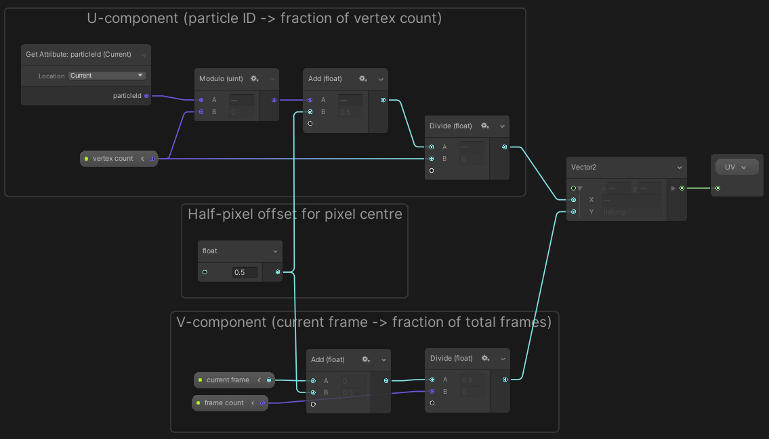

Fig. 2.11. Converting particleID and Frame to UV co-ordinates

For a simple xy -> uv mapping process, you are basically normalising by the vertex count and the frame count for x- and y-components, respectively.

To obtain the U-component value, we consider the current vertex based on the particle ID as each particle has its own count number in the VFX system. Therefore, if we modulo this ID by the vertex count we obtain a mapping of particles to vertices with particles over the vertex count just overlapping with the pre-existing particles.

Likewise, for the v-component, we take the previously determined current frame and normalize by the total frame count.

Finally, there is the addition of a half to both values before normalisation. This is to centre the UV-co-ordinates to the pixel centre and not the edge to prevent inaccurate frames (especially in the case of pixel-perfect textures).

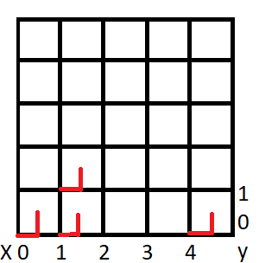

Fig. 2.11. The effect of the half-pixel offset when converting to UV co-ordinates

# Result of the VAT Generation Technique



Fig. 2.12. Example of a Vertex Animated particle system produced using my VAT Generation Script

# Even further beyond: VAT shaders for particles in a VAT VFX system

Traditionally, VAT is used for animating meshes using a shader to reduce the CPU load for many mesh instances. Now as the VFX particles are each their own mesh on the GPU, this means that we can use VAT in VFX Shader Graph shader for our output particle, which is a part of a VAT animated GPU particle system.

Unfortunately, in Unity 2020.1, the VFX Shader Graph does not allow for vertex position to be set of altered. Additionally, VFX graph also prevents you from using general URP shaders, so unless Unity 2020.2 allows for such functionality with Shader Graph this functionality is out of reach.

**UPDATE**

Unity 2020.2 is released! However, while the position node in the vertex shader is visible, it is greyed out, which means that functionality is disabled for the Visual Effects pipeline.

3. VFX Graph Force Feedback

# Part 3: Force Feedback Goal

Whilst having VFX particle systems adds a large amount of visual flair to a game, I decided to explore how a VFX particle system provides feedback and interesting gameplay to a player. My final vision is to produce a playable character comprised entirely of particles that can be affected by external forces such as CPU particles, with the affected particles returning to their initial position after a period. To begin this process, I want to make a particle system that is affected by an external force that offsets the particles from their desired position, and then after a time, will move to reform to their original position. This can used to demonstrate damage to a player character or impact of bullets onto a surface.

# Version 1: Offset by a force and return via toggle

In this phase I wanted to explore how to implement a lerp over a time that was not based on the lifetime of the particle as I want to have particles that have infinite lifetime.

## Exposed Parameters & Initial System State

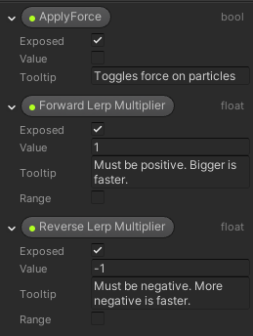 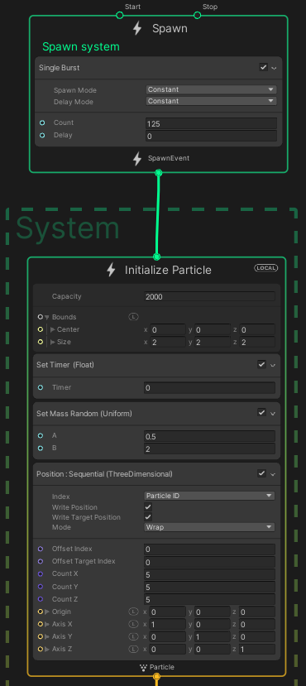

Fig. 3.1.1 Exposed Parameters and Initial Settings of VFX Graph

I have exposed parameters that allow for me to toggle which direction the lerp is progressing and the rates of each direction. As for the initial system state, I single burst spawn 125 particles and arrange them into a 5x5x5 cube. Note that this sets both the particles current position and its target position. This will allow for us to return to this position later as it is stored in Target Position. I give them randomized mass so that they spread more naturally with force later.

Finally, I set a custom float attribute called “Timer”. This attribute is constrained between 0 and1, and will control theprogress along the lerp. The use of a custom attribute is critical in more complex particle systems as you can set and get from them freely, which allows for better control of particle behaviour, especially when it comes to automating particle behaviour later.

## Update Behaviour

### Timer Control

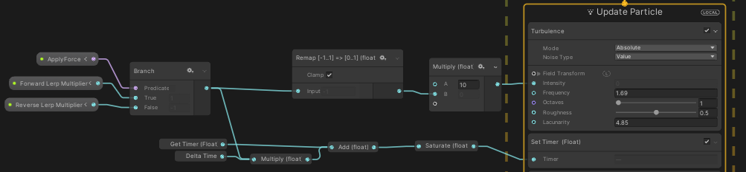

Fig. 3.1.2. Logic of the Turbulence Calculation and Timer custom variable

The direction of the timer is controlled by the ApplyForce Boolean. The branch value is remapped between 0 and 1 and used to control the intensity of the turbulence (the multiplication just makes it a bit stronger). The resultant effect is that the intensity of the turbulence is either 0 or positive depending on the ApplyForce.

The value of Timer is set every frame by increasing it by Deltatime*Lerp Multiplier and then using the saturate operator (clamps between 0 and 1). What this means is that the timer stays at 0 if the bool is false and increases over time until it reaches 1 when ApplyForce is True.

## Lerping Position and Velocity

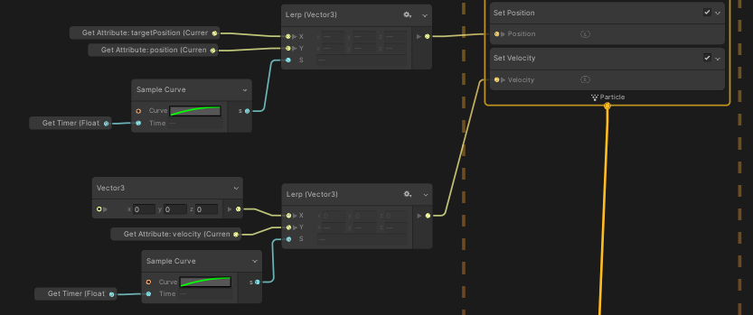

Fig. 3.1.3. Lerping current position and velocity by the Timer variable

Once the value of Timer has been set, the current position of the particle is set by lerping between the Target Position attribute (that we set via the Sequential Position block) and the current position attribute. The lerp rate is based off a curve that also has y-values between 0 and 1 so that we have more control over the tween rate of the lerp. The lerp makes it so that when timer has a value of 0, the particle as at its initial position in the cube (Target Position) and when the timer attribute has a value of 1, the particle is at its current position as calculated by the effect of the applied turbulence.

Likewise, a velocity adjustment was lerped in the same way so that when the particles are move back to their default position, they do not jitter in place due to having non-zero velocity. Additionally, lerping the velocity to non-zero values was required so that the evolution of the particles from the applied force occurs.

## Result



Fig. 3.1.4. Result effect of applying force and lerping to initial position

The final effect does the basics of what I want, however, there are some improvements to be made:

1. Force applied via collision
2. Jittering still present at low timer values
3. Make process not require a toggle to work

# Version 2: Offset by sphere collision and lerp to original position via toggle

To test external collision by colliders, I attempted to utilise a sphere collider and move it into the particles. This was done by replacing the Turbulence block with a collide with Sphere block that has an external Sphere parameter. This Sphere parameter was set using a VFX property binder that allows for scene properties to be bound to an exposed property in a VFX system.

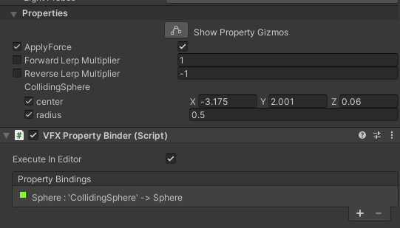

Fig. 3.2.1. Exposed parameters connected to VFX Property Binder for Sphere Collider

## Result



Fig. 3.2.2. Demonstration of particles moving into a stationary sphere



Fig. 3.2.3. Demonstration of particles not receiving force from dragged sphere

The problem with this method was that moving a sphere collider into the particles does not apply the momentum of the sphere to the particles, which just results in them being displaced. To address this issue, I decided to investigate using CPU particles as colliders. This will involve more in-depth scripting and complexity but should result in a more interesting effect.

# Version 3: Offset by an external CPU particle collision and then lerp back to original position automatically upon zero velocity

This version of particle collision is significantly more complex as the system is now fully automated with particles detecting when to lerp to their target positions automatically when achieving near zero velocity. The particles receive force via CPU particles imparting force onto a Collider component attached to the VFX Graph game object.

## The Main VFX Graph

### System Initialisation

The system is initialised in the same way as before except with a 10x10x10 cube this time. The main difference is there are now 5 custom attributes that are used to control the particle behaviour:

* Timer (float)
* Expand (bool): should particle be moving via force
* ColVel (Vector3): velocity of particle collision
* ColPos (Vector3): position of particle collision
* ColRadius (float): radius of effect of collision

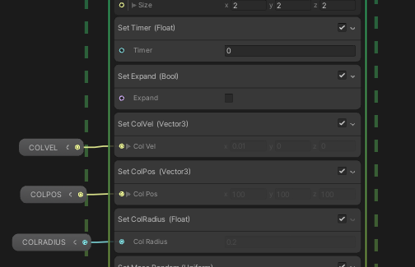

Fig. 3.3.1. Initialization of VFX graph parameters

The exposed parameters of COLVEL, COLPOS, and COLRADIUS are used to reset the values of the contact after initial contact has been made so that after a collision so that it does not affect the particles repeatedly. These parameters have default value:

* COLPOS: (100,100,100) [place contact point far away]
* COLVEL: (0.001,0,0) [make it very small (0 causes error due to 1/r)]
* COLRADIUS: 0.2f [arbitrary size to reset to]

### The Update Context

Each frame, the particle system does the following:

* Set the collision attributes if they have changed from their default values
* Calculate force based on contact parameters and apply to particle
* Check if it should be expanding or returning to default position
* Update timer based on Expand state
* Apply drag to slow down particles so they can begin to return
* Set position and velocity according to lerp via timer

#### Collision Information Logic

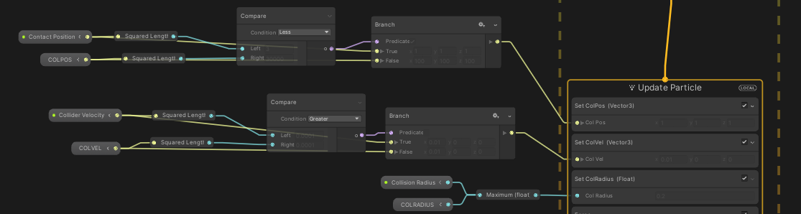

Fig. 3.3.2. Logic of Updating Collision Information

This logic effectively applies the collision attributes from the script on collision and resets them when the script resets the values to the original value to prevent a persistent collision event from occurring.

#### Force Calculation

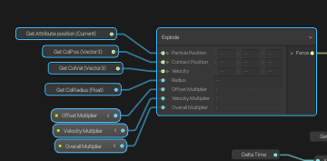

Fig. 3.3.3. The Input parameters for the Explode Subgraph

The Explode subgraph (explained later), calculates the force on a particle based on the input collision parameters and some multiplier that allow for scaling of different components of the force calculation. Offset multiplier changes the effect distance from the collision has, velocity multiplier alters the influence of the colliding particles velocity on the collision, and the overall multiplier just scales the result.

#### Should Particles be expanding?

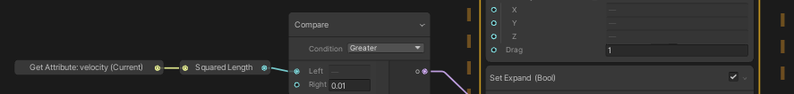

Fig. 3.3.4. Expand custom Boolean set according to current velocity

The condition for whether particle should still be expanding or not is basically just checking if they have stopped moving via velocity. This works as the lerp of position does not change the velocity from zero. Therefore, once a particle is shot out by the force, it is slowed by linear drag until it stops, after which it is then lerped back to the target position.

#### Timer Logic



Fig. 3.3.5. Timer logic for lerp control

The timer has been simplified from the previous iteration as I realised that a forward lerp is unnecessary as I want the force to drive the motion and not a lerp. Now the timer just keeps trying to increase toward 1, with the Expand Boolean keeping it at 0 if a force is being applied. Note that now 0 corresponds to expansion and 1 is for target position.

#### Slowing Down Particles

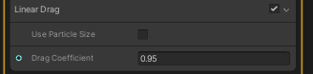

Fig. 3.3.6. Linear Drag co-efficient

Linear Drag effectively reduces a particles speed over travel distance. Important for a particle to stop expanding and begin the lerping process.

#### Setting Position

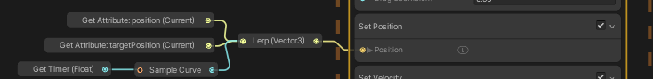

Fig. 3.3.7. Lerping position values by the Timer parameter

Position is set via the timer lerp as in the previous iteration, except the 0 position is the force affected one and the target position is at 1.

#### Setting Velocity

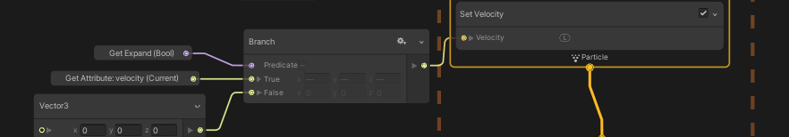

Fig. 3.3.8. Setting velocity by the Expand Boolean

The velocity no longer uses lerping to transition between stationary and movement states. Now zero velocity is enforced once expansion has stopped to prevent the jittering effect previously observed. Lerping was deemed unnecessary as going from 0.01 -> 0 velocity is unnoticeable.

## The Explode Subgraph

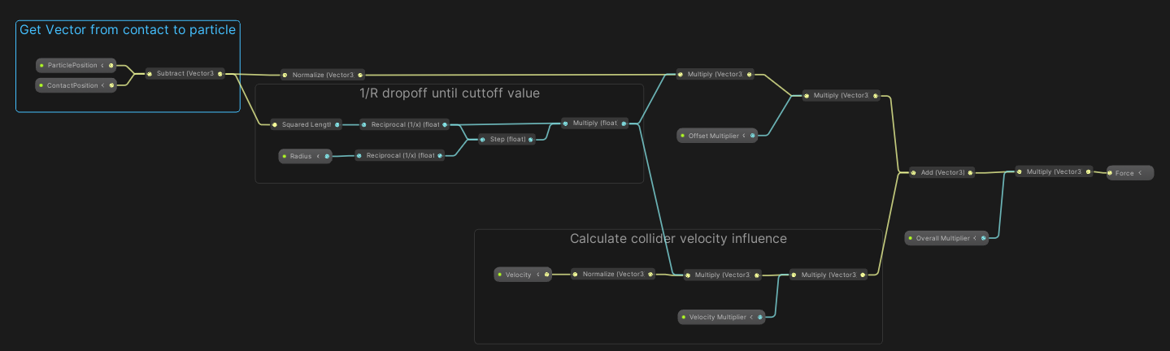

Fig. 3.3.8. Logic of the Explode Subgraph

The explode subgraph determines the force on a particle on contact. The main factor that determines this is the distance between the particle and the collision position. The steps to calculate the force are as follows:

1. Calculate vector between collision and particle (AB = B-A)
2. Calculate a 1/r dropoff effect so that particles at collision are effected more than those further away. Use step function to hard limit the maximum distance.
3. Calculate collision velocity direction, normalise by 1/r effect, and apply multiplier
4. Combine the 2 aspects of the force and apply multipliers where needed for further tweaking

Some notable weaknesses to this implementation are that the if Radius or distance from contact to particle are 0, it will calculate infinity, which is solved by adding an epsilon offset. Additionally, as effect is radial, it will also affect particles that are away from the surface, thus dot product in the direction of the collision velocity may fix this.

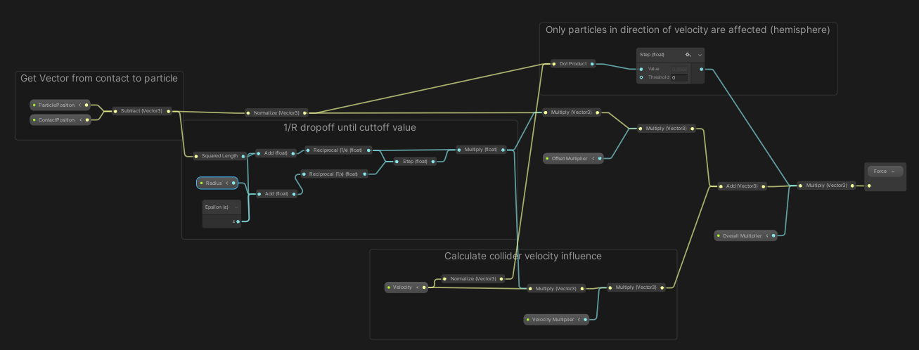

Fig. 3.3.8. Finalized Explode Subgraph

## Particle Collision Script

As this system is driven by CPU particles colliding with a collider, then passing that collision information to the VFX system; it is critical to understand how the script performing this works and its current limitations.

The core concepts to take away from the script are the Explode method, Reset Method, and the OnParticleCollision method.

The Explode and Reset Methods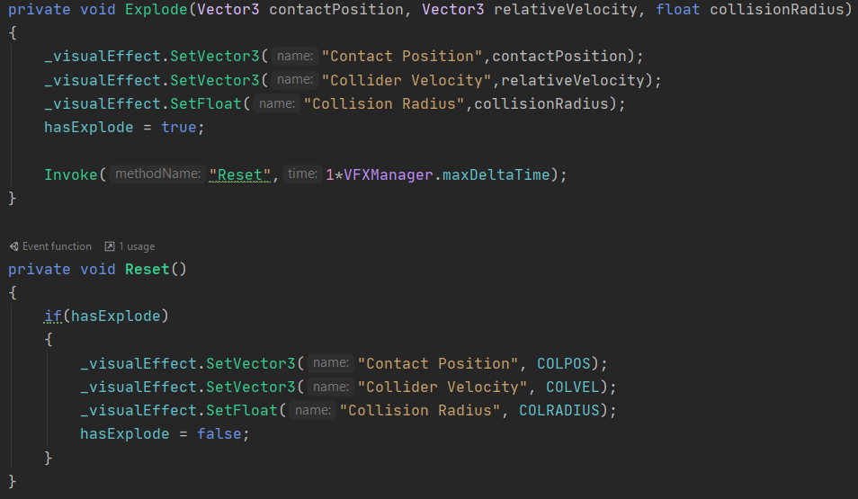

Fig. 3.3.9. Explode and Reset Methods in the Explode script

Explode and Reset work together as a unit, so it is beneficial explain them together. Explode takes a position, velocity, and radius input parameters. These parameters are then sent to our VFX systems exposed parameters mentioned earlier. Once this is done, we note that an explosion has occurred and that resetting will need to occur to prevent successive contacts. After one VFX frame, Reset is invoked, which resets the input parameters to the default values and sets hasExplode to false.

The Reset method is critical to prevent collisions from staying in one place until they are overridden. I want them active for one frame, and then to disappear after they have done their effect.

### A word about Timescales

Speaking of waiting for one frame, from coding this script I learnt that there are 3 time scales in the Unity Engine. The standard time scale, physics time scale, and the VFX time scale. To make this script work, I set the maxDeltaTime of the VFX time scale match that of the physics time scale so that the VFX system and physics system update at the same rate (60 fps was chosen for this).

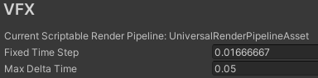 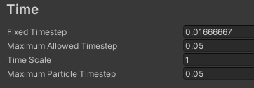

Fig. 3.3.10. Different Timescales in Unity

Note that I chose the max delta time so as to reduce missed frames where the delay is faster than the physics frame rate so as to not skip a collision event.

### Handling Particle Collision

Unity handles the callback information from a particle collision much in the same way as a normal OnColliderEnter method via OnParticleCollision(GameObject other).

For this method to receive information, first your CPU particle system must do the following:

1. Have world collision enabled
2. Collide with the layer that you are interested in
3. Send Collision Messages

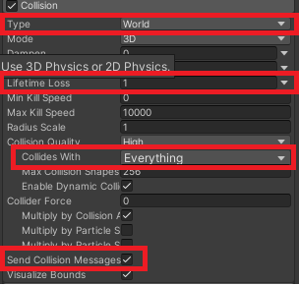

Fig. 3.3.11. CPU Particle Collision settings to enable OnParticleCollision callbacks

Once these properties of the particle system are set up, then you are good to go.

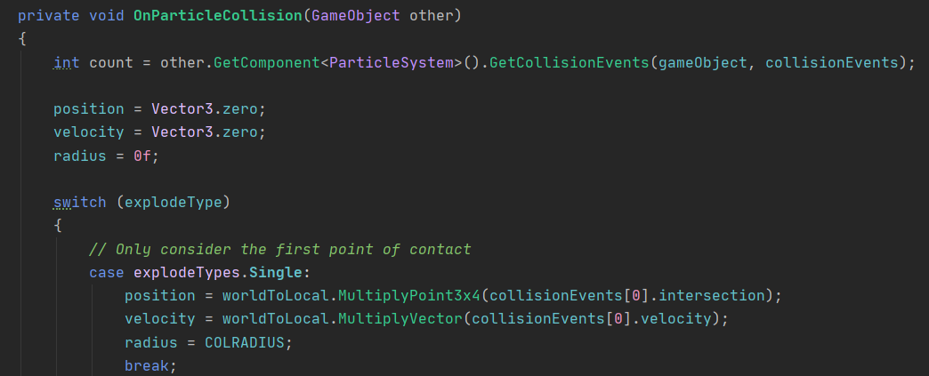

Fig. 3.3.12. OnParticleCollision method

In the OnParticleCollision method, the input GameObject is the gameobject that is sending out the particle system that is colliding with the current gameobjects collider. The way a OnParticleCollision method works is that on a given frame that has a particle collision, all collisions on that frame are stored in a CollisionEvents list that corresponds to the contacts with this gameobject’s collider and are stored in the particle system so that it knows how to influence the particles with regards to the collider.

These collision events are stored in a List called collisionEvents via the GetCollisionEvents() method using the “out” keyword which acts like a pass by reference.

To begin with, I am only considering the first collision event of a frame as seen via collisionEvent[0]. Then I extract the intersection and velocities of the collision event, convert them from world space to local space, store them into parameters than are then sent to the Explode method.

## Result



Fig. 3.3.13. Result of a single particle collision on the VFX system

The final result of all of the previous steps is that we now have a vfx particles system that responds to external CUP particle collision, where the particles are locally affected by the collision, receive a force and then revert back to their original state over time.

Current flaws with this approach:

1. If more than one collision event occurs on a given frame, then only the first is considered
2. Can only calculate one force vector, which means only one collision position can be considered a frame

To begin with, lets try and address the first flaw of have many simultaneous contacts a la a shotgun. I first approached this with a simple averaging approach.

# Version 4: Offset by multiple simultaneous external cpu particle collisions and then lerp back to original position automatically via averaging

The averaging approach is basically the same as with the single hit approach, but by averaging over the position, velocity, and radius of all collision events of that frame. Position and velocity averages were trivial; with the radius calculation being the average distance from the average position to the collision positions. This was done storing the transformed positions into a list during the average position calculation. Then by looping over that list, I calculated the average distance from the average position and each contact position.

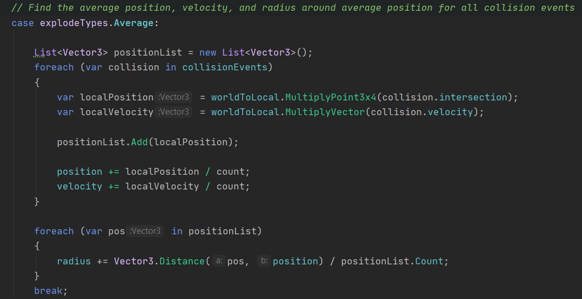

Fig. 3.4.1. OnParticleCollision method using an averaging approach

## Result



Fig. 3.4.2. Result of the averaging approach for multiple collisions

The result of this averaging is a much larger impact area, which while achieving a bigger effect than the singular and looks visually consistent; however, this approach falls apart under the scenario of simultaneous particle collisions on opposite sides of the collider. These should average out to the centre and have minimal effect.



Fig. 3.4.2. Incorrect averaging of position for collisions on multiple sides

To remedy this short coming, I needed to greatly rework system to accommodate multiple positions and velocities simultaneously within 1 vfx frame. My approach to this was inspired by the VAT generation and reading process; to store the information into a small texture on collision and pass that in to my VFX system.

# Version 5: Offset by multiple simultaneous external cpu particle collisions and then lerp back to original position automatically via individual consideration

To achieve this effect via Texture reading and writing; I needed to first workout how to write the texture. My main concern with approach would be that making and altering a texture would be too slow; but luckily it is the saving process that is slow, and I do not need to save this texture at runtime.

## Texture Generation and Texture Reset

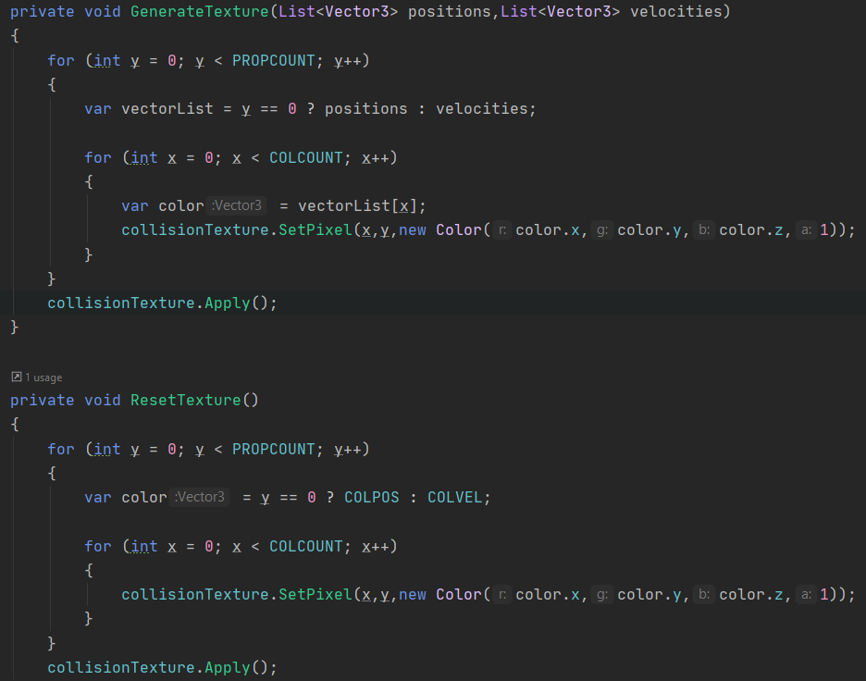

Fig. 3.5.1. Generating a texture to store collision information for the VFX graph

Basically, I have a collision texture that for each collision until a designated count (explained later) that stores the position and velocity as a color with y=0 being position and y=1 being velocity. The GenerateTexture method takes a position and velocity list, and writes the pixels as previously described. ResetTexture does the same thing, except just writes the default COLPOS and COLVEL values to the corresponding pixels for all collisions.

## Particle Collision

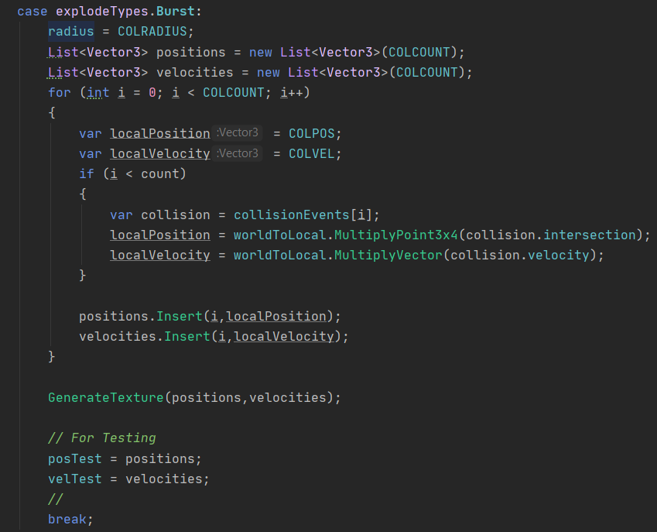

Fig. 3.5.2. Writing the textures during OnParticleCollision

Particle collision is very similar where each collision event is looped over and the position/velocities are extracted. The big difference is that I am defaulting the values to COLVEL and COLPOS so that if the collisionEvents count is smaller than COLCOUNT, I do not get an access exception error. This is needed because I can only consider a specific number of collisions, and more or less than that could be problematic.

Once these positions/velocities are stored into a list, the texture is generated and then Explode is called after the case is broken.

## Explode/Reset

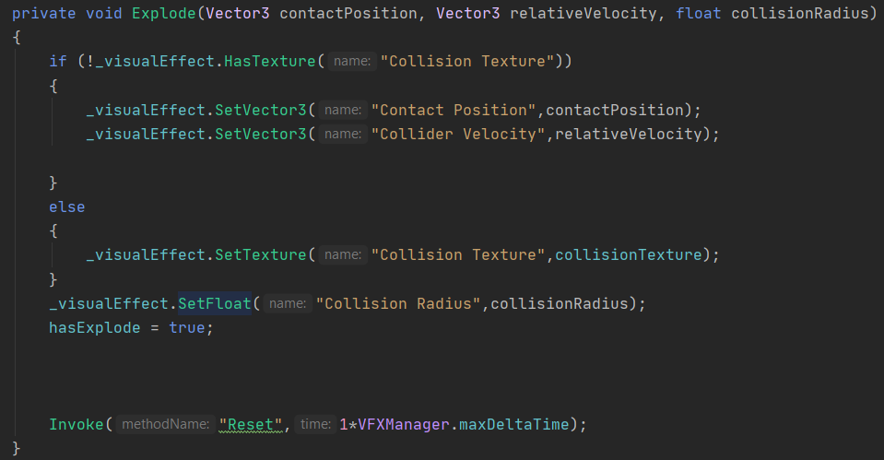

Fig. 3.5.3. Passing the texture during the Explode method

I wrote this script with being able to switch modes in mind, so I need to check if a texture is being exposed in the VFX system. If there is a texture, then I pass in our collisionTexture. And the radius as well. The rest proceeds as normal.

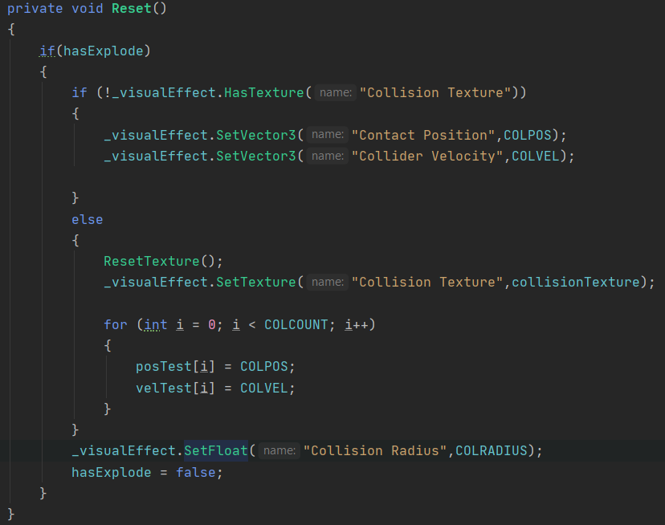

Fig. 3.5.4. Passing the texture during the Reset method

Reset is done in much the same way, except with ResetTexture() being called and then the texture is passed into the VFX system.

## The VFX System

Now that the texture is in the system, now we need to read from it and apply the values correctly. From my reading and understanding of VFX graph, there is no obvious way to loop over and apply an arbitrary number of forces. As such, we need to specify the maximum number of forces we want to calculate each frame simultaneously. For the current implementation, I have chosen 5 simultaneous collisions. This can be increased, but it is tedious as will be shown later.

For the VFX system, the initialization is the same as the previous cases as the only new exposed parameter is the collision texture. The only difference for the graph is in the Update context where the single Force block has been replaced by a custom Block subgraph “IndividualForceBlockSubgraph”.

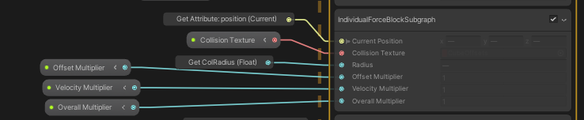

Fig. 3.5.5. Passing the collision texture into the IndividualForceBlock Subgraph

Block subgraphs allow for more detailed block(s) to be compacted into a single block and reused in different VFX graphs more easily.

### Individual Force Block Subgraph

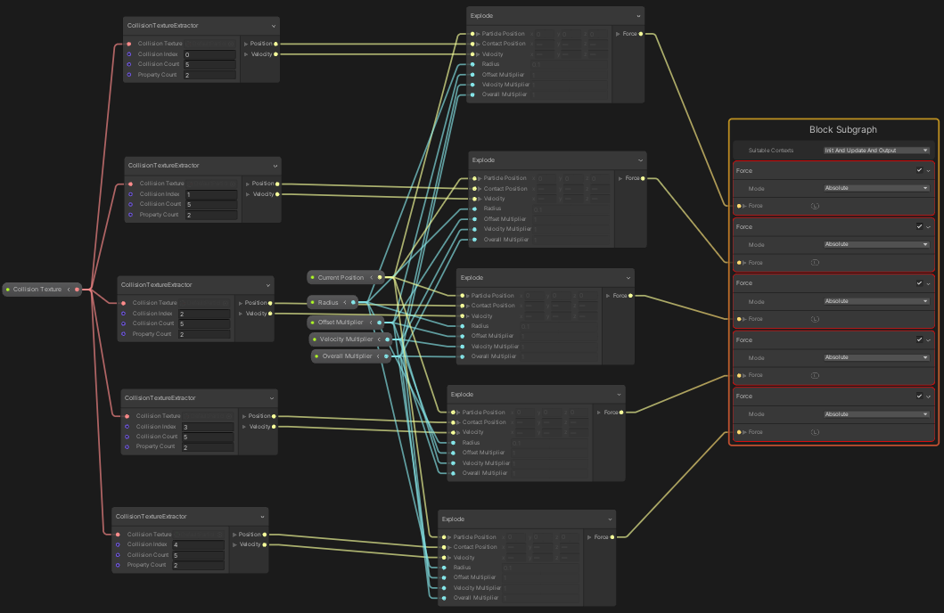

Fig. 3.5.6. Logic of the IndividualForceBlockSubgraph with exactly 5 Force blocks

While this block subgraph looks very messy, it is thankfully very simple. It takes a texture, then read the texture via a custom CollisionTextureExtractor operator, which returns a position and velocity corresponding to the collision index. These values are then fed into the Explode operator which returns a force vector which then feeds a Force block. This process is repeated 5 times as I decided that considering 5 simultaneous collision events will be enough per frame. Of course, this number can be expanded although it is tedious.

### Collision Texture Extractor

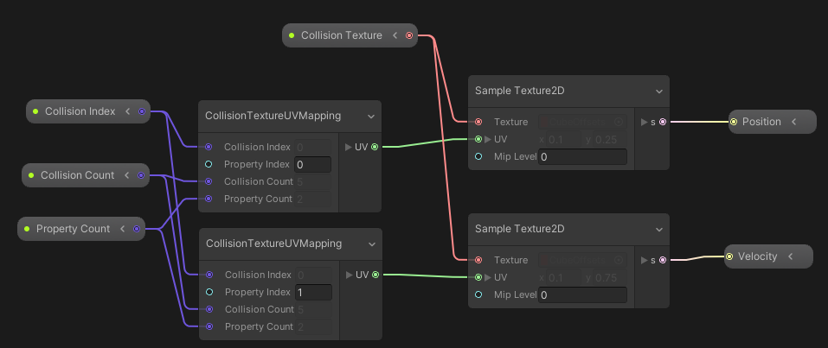

Fig. 3.5.7. Logic to read the Collision Texture to extract the position and velocity of a collision event

Pass in texture, collision index, and the number of collisions and properties to extract and return the position/velocity from the color in the texture via Sample Texture 2D.

The UV of the collision texture is done via the CollisionTextureUVMapping operator.

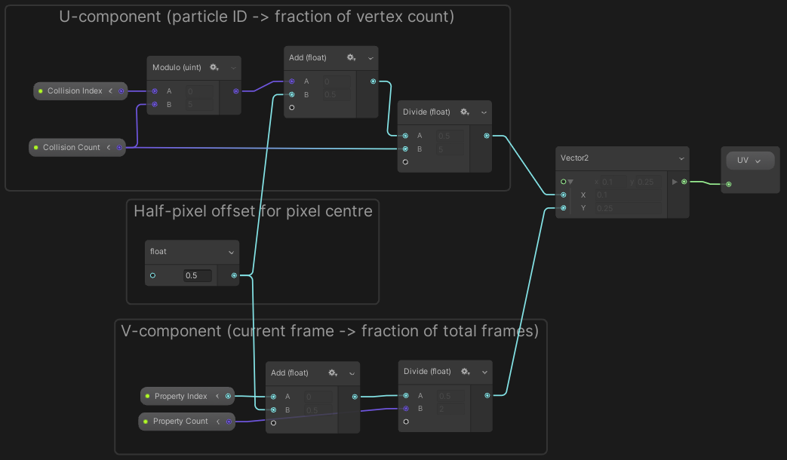

Fig. 3.5.8. Determine UV co-ordinates of the collisions texture

Which basically works the same as the VAT UV mapping operator I made previously.

$$u=\frac{\left(x mod w\right)+0.5}{w} , v=\frac{y+0.5}{h}$$

## Result



Fig. 3.5.9. Correction of the previous edge-case

This approach has remedied the shortcomings of the previous approach as now opposing simultaneous contacts do not average out to the centre.



Fig. 3.5.10. Demonstration of result with rapid collision application

It also works fine with rapid particle collisions with no obvious artifacting or deviances. Now that we have a working collision detection with position reformation, we need to have an animated character to apply it to.

# Version 6: Combine Collision Effects with VAT animated VFX system

Now we combine the collision effect with the VAT controlled particle system. To do this, the core idea is to use the VAT to set the Target Position of the particles every frame according to the VAT.

To do this, I converted the previous VAT reading process into its own subgraph block to make things cleaner. This subgraph block is used in initialize and update with position being initially set to the target position. All this block does is read from the VAT and assign the position obtained to the Target position.

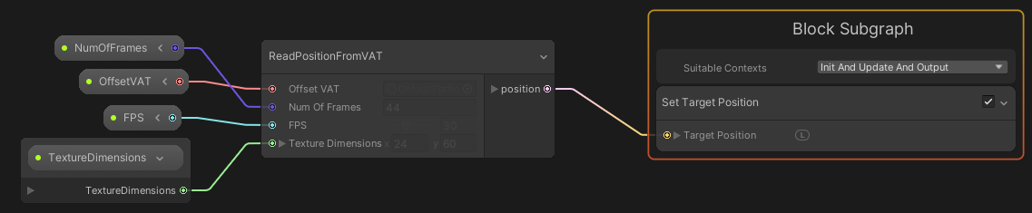

Fig. 3.6.1. Read target position from a supplied VAT at a given frame rate.

## Result



Fig. 3.6.2. We now have an animated VFX character in a looping animation that is affected by CPU particle forces and reforms correctly.

Now we have a VFX particle system that animates according to a VAT whilst also receiving forces from external CPU particles, with the particles returning to the target position once they slow down enough. Now that a single animation has been read and applied correctly, we need to be able to transition between animations.

# 7. Transitioning between VAT textures according to script

Switching out the VAT for another texture is trivially easy; however, lerping between 2 animations as done by the Unity Animator will be notably trickier.

What needs to be done is the following:

1. Two textures need to be stored:
   1. Current Animation
   2. Next Animation
2. Need a lerp factor between the two
3. Either done by lerping the values of the textures in script or done within vfx graph.
4. Once the lerp is done, the current VAT is replaced by the new VAT and the lerp value is reset to 0
5. Additionally, the frame count should be synced to the new animation frame

## 7a. Animation Transition via VFX Graph Toggle

To better understand the process of what I wanted to do, I began by trying to allow for the transition back and forth between two VAT positions according to a toggle. I wanted the transitions to happen over time, and be reversable. Additionally, each animation should have its own timer, with the Idle state being continuous and the second state only beginning to animate while the toggle is true and to return to its 0th frame otherwise.

### Initialization

Above the parameters used in the previous version of the system that are related to the collision/reformation functionality, I have introduced 3 new custom attributes: VATTime1, VATTime2, and IsTransition. The first two attributes are timers that I use to animate the first and second VAT samples respectively; whereas the 3rd controls whether to switch to the second VAT or not.

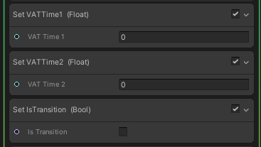

Fig. 3.7a.1. Initializing VAT transition parameters

### Update Context

The Update context can be split up into a few different steps:

1. Are we changing to a new animation
2. How far along the lerp transition are we
3. Update the Timer for VAT 1
4. Update Timer for VAT 2
5. Set target position according to the lerp between the two extracted VAT positions
6. Apply Collision and Reform logic

The first step is just setting the IsTransition attribute via an exposed bool toggle.

The second step is a bit more complicated, but it is basically to set a custom TransitionLerp float attribute according to if the transition is occurring. If IsTransition is true, then the lerp increases over time until it reaches 1, else it decreases over time until it equals 0. This rate is altered according to an exposed TransitionTime property.

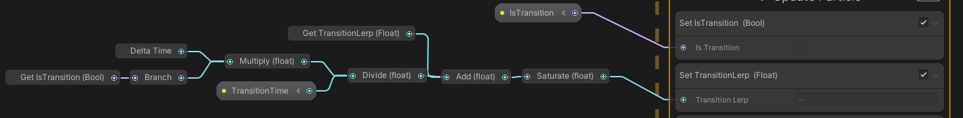

Fig. 3.7a.2. Logic to set the TransitionLerp custom attribute

The third step is just a simple Time = Time + delta time, nothing special here.

The fourth step is more nuanced as we don’t want to move into the second animation that is halfway through, especially for the currently used Shoot animation. Basically, if IsTransition is true, then delta time is added to VATTime2, else it I just pass VATTime2. The timer is clamped between 0 and the length of the animation (FPS * Frame Count). Then finally, I check to see if the Transition Lerp is greater than 0, as if so I want to the timer to increase, otherwise I return 0 as I want the animation to be back at the beginning.

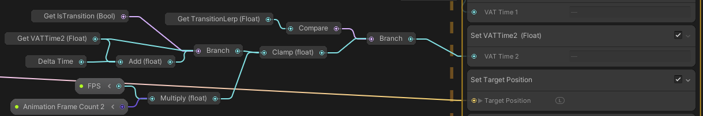

Fig. 3.7a.2. Logic to set the VATTime2 custom attribute to prevent transitioning midway through the next VAT animation

Finally, setting the Target position is done by lerping between the position extracted from each VAT according to the TransitionLerp value previous calculated. Each VAT is read at the same frame rate, with their own texture, frame count, texture dimensions and Timer.

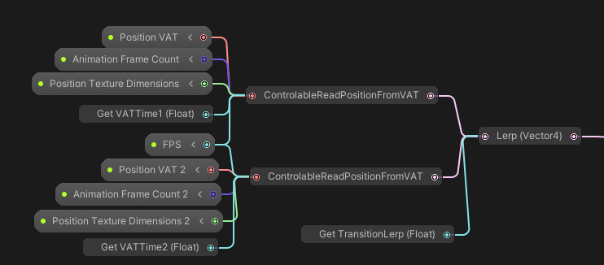

Fig. 3.7a.3. Lerp logic for setting the TargetPosition of the particle

ControlableReadPositionFromVAT is the same functionally as ReadPositionFromVAT, except it takes a float for the time to know what frame it is up to. I also found that my old current frame calculation was redundant and has been simplified to FPS*Time which makes sense as FPS literally means Frames per second.

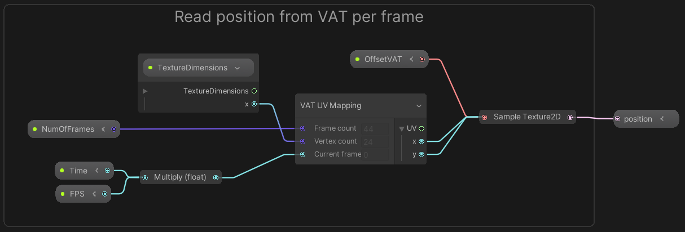

Fig. 3.7a.4. Logic for ControllableReadPositionFromVAT to read a position from a VAT for a given Time float rather than the particle lifetime

### Result



Fig. 3.7a.5. Resulting effect with a toggle to transition between two VAT animations

## 7b. Animation Transition via Script

So, now that I have a better idea of how to transition between two VAT positions smoothly, I next wanted to make the system more flexible to allow for different VATs to be switched out to animate the VFX system similarly to the Unity Animator system. Since Texture2Ds can’t be stored into custom attributes, the only way to change the textures is to use script logic. I did also consider using a Texture2DArray for this, however that requires that all textures have the exact same dimensions, which would require me to adjust my texture generation process; which I deemed to be unnecessary as of the moment.

The goal of this iteration is to allow for transitions from a current animation to a new animation, and then set the current animation to the new animation. This system should also allow for one shot and looping animation transitions, with the former reverting back to the previous animation upon completion. Additionally, animations should be interruptible and always start from the beginning of the new animation.

### VFX System

The VFX system compared to the previous one has been stripped down to just the set target position block, as all of the timer logic has now been exported to script and the timer/lerp values are now being controlled by exposed parameters.

Also note the Collision/Reform logic has also been encapsulated into a subgraph block to clean up the VFX graph.

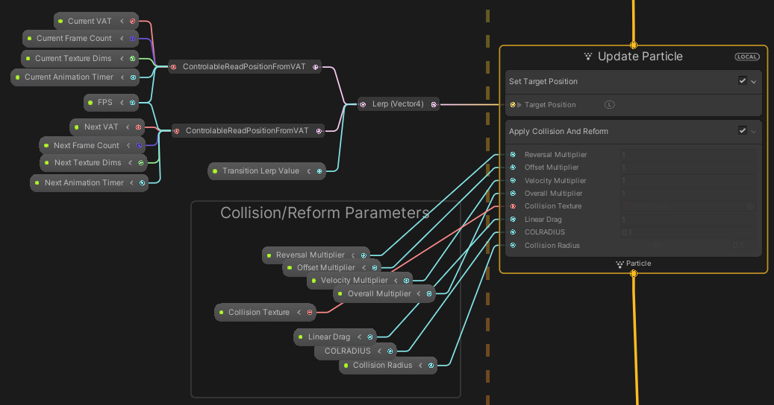

Fig. 3.7b.1. Stripped down logic of VFX Graph with Collision logic in subgraph block

### VFX Animation Transition Script Logic

The script logic is basically to lerp between a current VAT to the next VAT over a given time frame. Additionally, the next VAT animation needs to begin playing when the lerp begins and be at 0s otherwise so that the transition doesn’t occur mid animation. Lastly, the script needs to allow for one-shot animations that return to the previous animation upon completion.

#### Initialize Current VAT

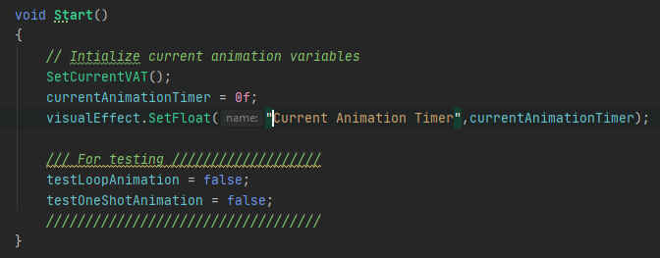

Fig. 3.7b.2. Initialize VFX animation parameters

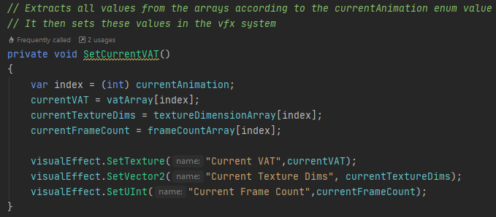

Fig. 3.7b.3. SetCurrentVAT method for initializing parameters for the current VAT

In start we initialize the current VAT parameters and timer via accessing arrays that contain the relevant texture information for each VAT according to the currentAnimation enum.

#### Update function

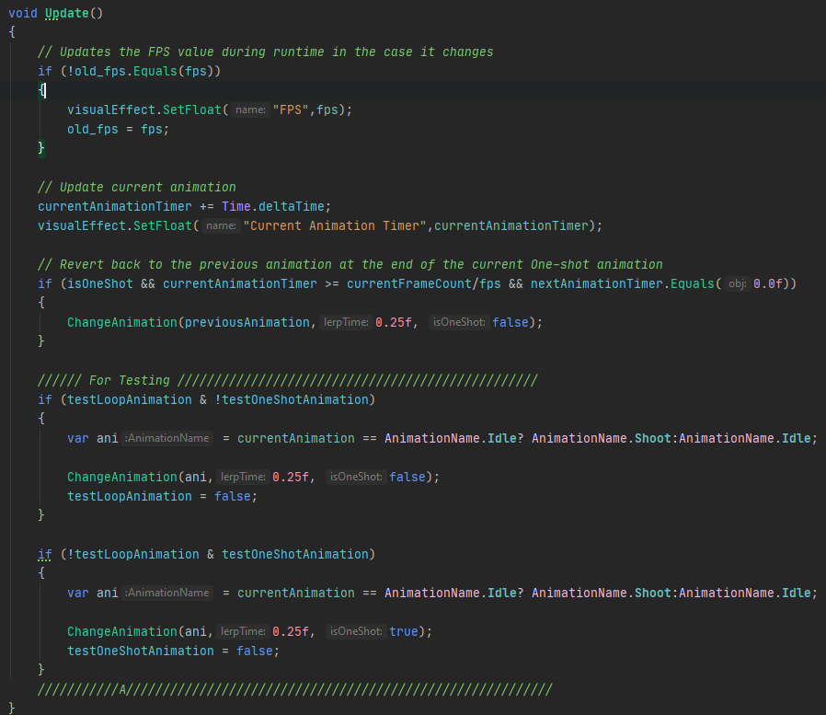

Fig. 3.7b.4. The Update function for VFXAnimationTransition

The update function allows for updating the FPS of animations if they change during runtime, incrementing and updating the current animation timer, and reverting back to the previous animation when a One-shot animation is completed.

#### ChangeAnimation function

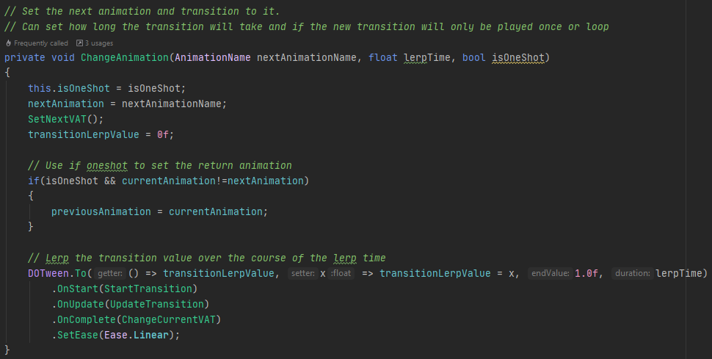

Fig. 3.7b.5. The ChangeAnimation function to lerp between VATs

This function is the core function of this script, and begins the animation transition procedure. The function sets the next animation parameters according to the input parameters when called, resets the lerp value, and sets the previousAnimation to the current in the case of a one-shot animation so that it can be returned to. Finally, it utilises the DOTween library to tween the transitionLerpValue from 0 to 1 over lerpTime seconds. DOTween has the additional features of allowing for event-based logic upon the start, update, and completion of the tween.

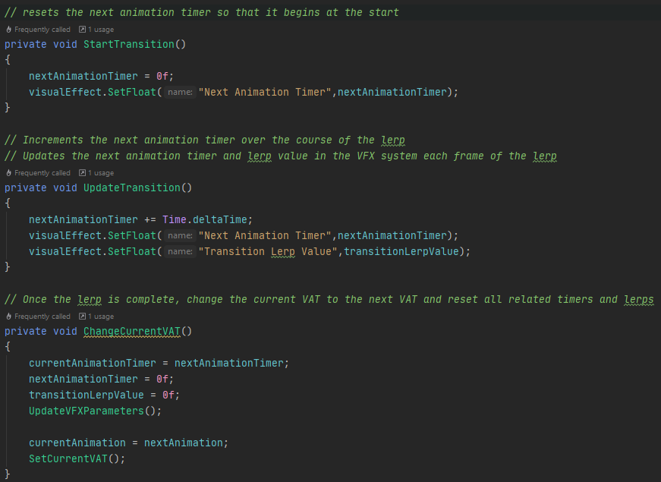

Fig. 3.7b.6. Methods to be called during the DOTween events

The StartTransition and UpdateTransition basically update the timers over the course of the lerp, and the ChangeCurrentVAT manages the switch from the Current VAT to the next VAT along with resetting the timer values and setting current timer to the next timer so that the next animation doesn’t restart or stutter once the lerp is complete.

### Result



Fig. 3.7b.7. Result for VAT transitions using script logic

The result is a system that allows for a transition between 2 animations along with looping or one-shot capabilities.

Improvements that can be made are:

* Connect to character controller
* Synchronize with rigged animations/colliders in the animation to allow for character/world feedback

# 8. VFX system with movement via script

In order to begin creating a character controller, I needed to create a movement script that does the following:

* Uses the new input system to move the player and perform actions (idle, moving, jumping, shooting)
* Update the variables in the VFX system so that the appropriate VAT plays based on the input actions

This iteration did not require any alterations to the VFX system, only a Movement script for inputs to be passed to a collider/rigidbody component system.

## Initialization of the Movement Script

The script starts by initializing the VFX animation system and the player input system; where the former just caches the VFXAnimationTransition and initializes the VAT to the Idle state.

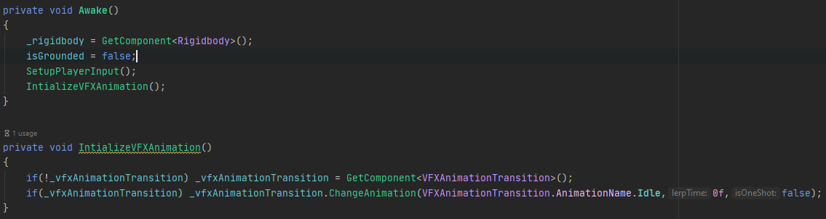

Fig. 3.8.1. Setting up the input system and initializing the VFX system

## Input Setup

For the SetUpPlayerInput method, the idea is to cache the PlayerInput component and its Action Map; where the action map contains all control schemes and actions for the Player Input. From this action map, we then cache the Input Actions we wish to use, which in this case is Move, Jump, and Fire; which are accessed just like a dictionary. Finally, the the Jump and Fire methods are assigned as delegates to the “started” events of their respective Input Actions.

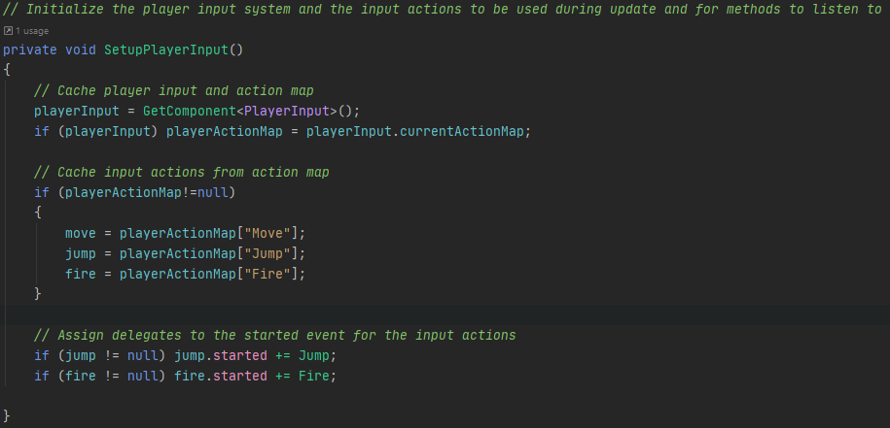

Fig. 3.8.2. Setting up the input system via the New Input System for Unity

For both methods, they take InputAction.CallbackContext context as an input parameter as it is required for delegation to an InputAction.

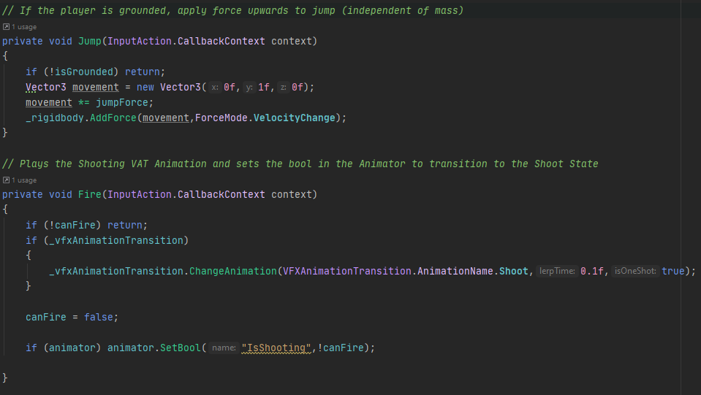

Fig. 3.8.3. Event-based Jump and Fire methods

From here, Jump just applies an upwards impulse force if player is grounded. Fire checks if the player can shoot, if they can shoot, the animation is changed to the Shoot animation and canFire is set to false.

The isGrounded state is checked via Raycast each frame, and canFire is reset to true based on a timer. These are all checked in Update as well as the implementation of Move() as well.

## Update

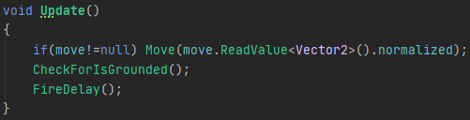

Fig. 3.8.4. Update movement, grounding, and if firing is possible

In this method, the Move() method takes a Vector2 which is read and normalized directly from the move input action from the player action map.

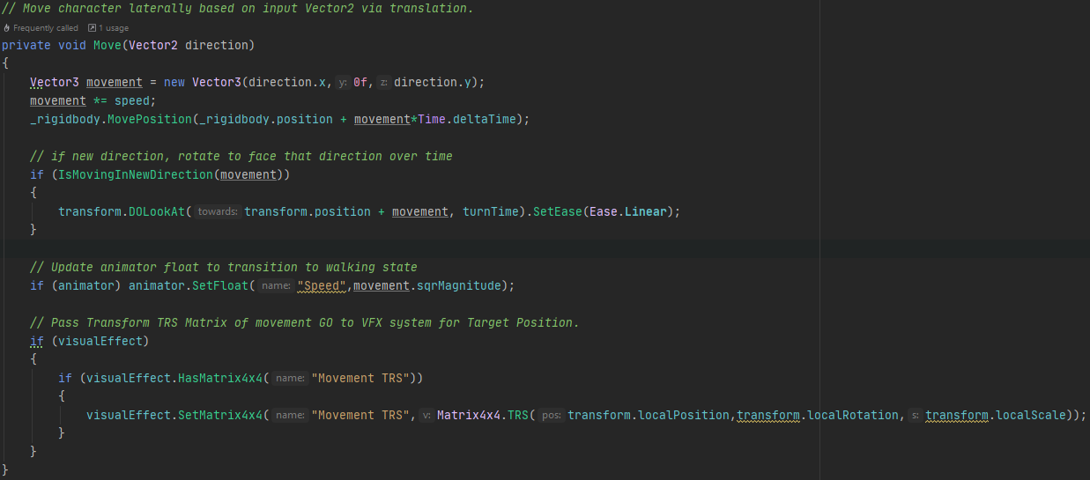

Fig. 3.8.5. Move method

The Move method is quite simple for the part we are currently concerned with. First, the Vector2 is converted to a lateral vector3, and applied to the Rigidbody via MovePosition each frame. Then if the direction is new, then we use DOTween to lerp the transform rotation to face the direction of movement. The rest will be explained in later iterations.

The IsGrounded check and FireDelay Timer are standard and self-explanatory.

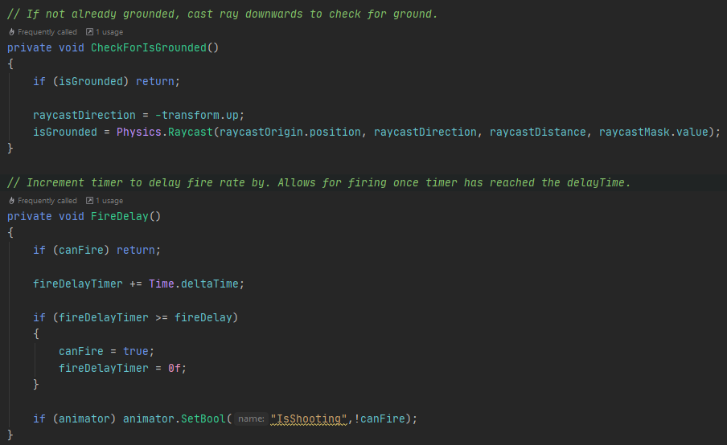

Fig. 3.8.6. Determine if grounded via raycast or can fire via timer

## Result



Fig. 3.8.7. Moving character with different animations based on inputs

The end result is a player controlled character that can move and transition between VAT animations via player inputs.

Limitations:

* The particles once they are scattered follow along with the movement of the player and does not feel natural as they are not disconnected



Fig. 3.8.8. Demonstration of particles following transform unnaturally

* During the shoot animation, it would be cool if it shot particles itself
  + Would rather than a static capsule be best done via animation function call via Animator system
* Animator system would allow for colliders that follow the VAT animation

# 9. VFX system with movement connected to Animator

So, I decided to start with the easy shortcoming first and implement the Animator functionality to the system.

Basically, all that I did was the following:

* Create a ShotOrigin Gameobject that has an attached particle system that fires a burst of CPU particles that can collide with other systems. This system was positioned at the mouth of the octopus character during the Shoot animation.
* Gave the gameobject a simple animator with 3 states:
  + Idle
  + Walk (same as idle for now)
  + Shoot

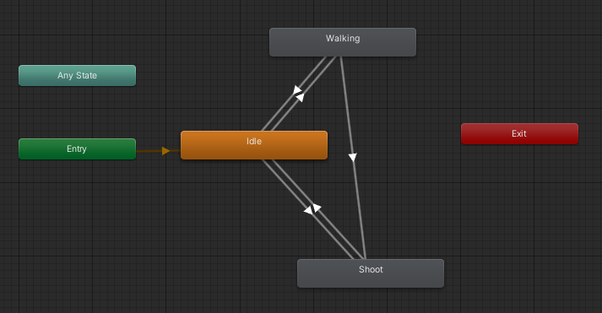

Fig. 3.9.1. Early Character animator controller

* These animations have the same number of frames as the VAT textures with the same FPS.
* During the Shoot Animation, an Animation event on frame 28 calls the FireProjectile Method that just plays the particle system.

For the shot to be independent of the root gameobjects transform (note: world simulation space does not fix for parent of parent transform), I instantiate a shotEmitter gameobject with a particle system in the scene which is then destroyed once all particles are no longer alive.

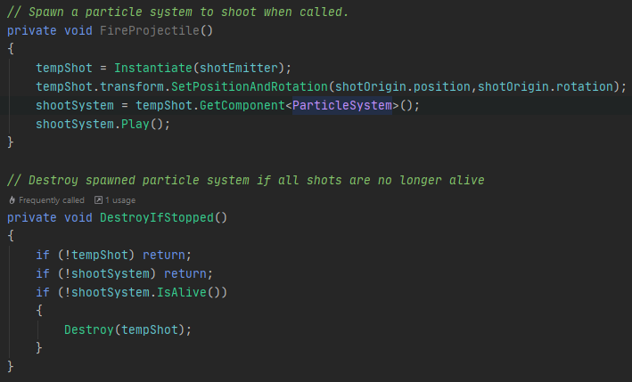

Fig. 3.9.2. FireProjectile Method called via Animation Event

## Result



Fig. 3.9.3. Resultant particles spawned for shooting

# 10. Separation of Movement & VFX for World Scattering

The next shortcoming to tackle is that of the particles following the system as it moves around after they have been scattered. The concept is to have the position of the particles be simulated in their own space and have the target position be transformed from the VFX local space to the Movement local space. My approach to this was to do the following:

* Separate the gameobject components into 2 children GOS:
  + Movement
    - Player Input, rigid body, collider
    - Movement script
    - Animator
    - Explode Individual script (with connection to Visual Effect + VAT Transition)
  + VFX
    - Visual Effect
    - VFX Animation Transition script

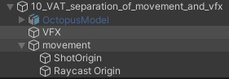

Fig. 3.10.1. Modular GameObject layout to separate VFX from Movement

* Transform the Target position in the VFX system by an exposed TRS Matrix4x4
  + This matrix is set by the movement script.

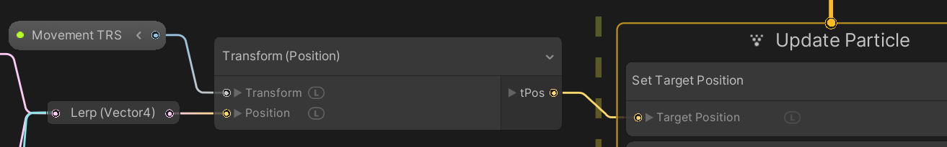

Fig. 3.10.2. Transformation of Target Position by TRS matrix of Movement Gameobject

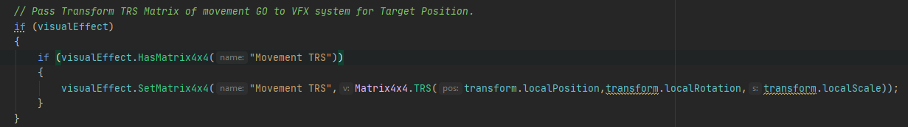

Fig. 3.10.3. Setting MovementTRS Matrix in Movement script

* As the collider and VFX are in different local spaces, the collision position needs to be now transformed by the Visual Effect TRS and not the collider TRS for the Explode Method to work correctly.

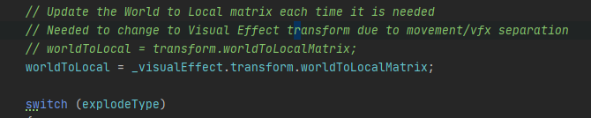

Fig. 3.10.4. Explode TRS matrix now based on VFX gameobject rather than movement

During this implementation, I found that if the player moves too far from the VFX position, they leave the bounds of the VFX system, and disappear. However, I found that even if you turn on the Culling Flag of “Always recompute bounds and simulate”, they system is still culled at some viewing angles.

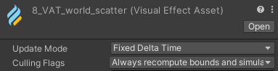

Fig. 3.10.5. Prevent particles form not being simulated if not visible

The reason for this is that Unity always culls VFX systems if it believes that none of the system is being rendered. Unity determines if a VFX system is being rendered if the camera can see the system bounds, that is, the camera frustum intersects the system bounds.



Fig. 3.10.5. Demonstration of Unity culling all particles in a system if bounds are not visible by the camera

The solution to this is to ensure that the bounds is either so big that the camera always sees it or to have the position of the bounds follow that of the camera. The problem with the latter is it follows the position of the Main Camera, so that means when observing through the scene view, the system can disappear as the scene camera is not the main camera. Therefore, I decided to implement both solutions as in my research I could find no reason why not to have an arbitrarily large bounds other than rendering a system that is smaller than a pixel in size. However, in the case of a player, we want the camera to follow the system around and therefore it does not matter.

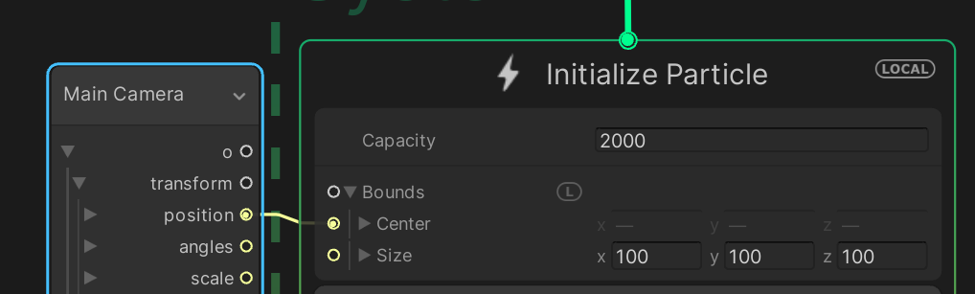

Fig. 3.10.6. Solution to Unity bounds culling

## Result



Fig. 3.10.7. Particles now do not follow player, only once returning to target position

So now we have a player character that will always be visible, can take actions and animate, fire particles, and will scatter and reform in world space.

The final limitation as I can current see for this system is that the player currently only uses a single capsule collider for hit detection, which is fine for a simple model like this one; however, it is inflexible for a more detailed humanoid model as the collision hitbox should also animate with the system.



Fig. 3.10.7. Simple collision method for a simple model

# 11. Animating colliders for more natural particle collisions and gameplay interactions

To have finer detail for the collisions on the particle system, I will need a more detailed collider system than the single capsule collider I currently have. Additionally, as I also have a working integrated Animator set up, the simplest way would be to animate the positions of the colliders to either match the animations or to use a rigged model and attach the colliders to the bones/joints which themselves are animated.

The tricky part of this implementation is that the OnParticleCollision method is for the colliders attached to gameobject that the script is attached to. As such, I will being by seeing if having multiple Individual Explode scripts will allow for the effect I want; however I could see an issue where 2 simulatenous collisions on different colliders override each other in exposed VFX inputs. As such, it might be better for each collider to have a smaller script that send the converted positions to another script that forwards the first 5 or so to the VFX system.

Another cool thing with this kind of approach is that I can turn off colliders to change the gameplay of the character and prevent particles from hitting thin air.

To begin this whole process though, I’m going to need a simple humanoid with some animations and rigging to test.

## Creating A Blender Character

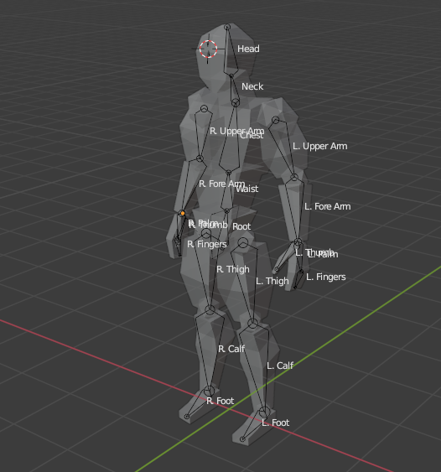

Fig. 3.11.1. My low-poly human I made in Blender with armature

I created a low poly human model in blender (shown above) following the techniques shown in <https://www.youtube.com/watch?v=4OUYOKGl7x0> . I connected the model to an armature comprised of bones that allow for the mesh to deform. First, I parent the mesh blocks to the bone, however this resulted in many child mesh game objects in Unity; which was undesirable for my purposes. So I joined the mesh blocks together into a singular mesh so that Unity can detect that it needs to convert the mesh to a SkinnedMeshRenderer. This however did require for me to weight paint each vertex to the bone that I wanted to affect it, which was notably more time consuming but finally resulted in a skinned mesh that can be manipulated in Unity and read by my VATGeneration script.

## Animating the Character

Now as animating each animation clip would be time consuming, I decided to utilise Mixamo for my animation needs. My steps for ensuring that my animations work properly with Mixamo were the following:

1. Load your model to mixamo
2. Apply a T-pose animation to your character model and download the FBX file (I preferred the non-unity one)
3. Use this T-Pose animation to create a Humanoid Avatar
4. Download the rest of the animations you wish to use and apply the created avatar to the Rig.

Once these have been downloaded, I created an animation controller and updated the movement script to allow for jumping and falling.

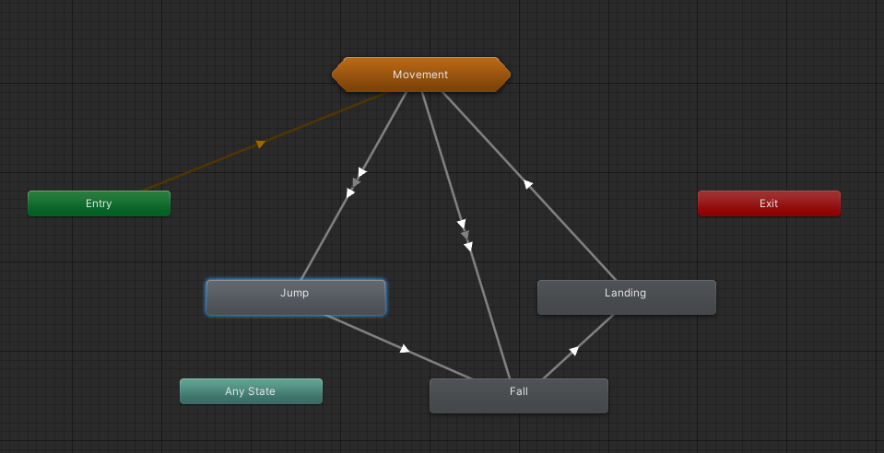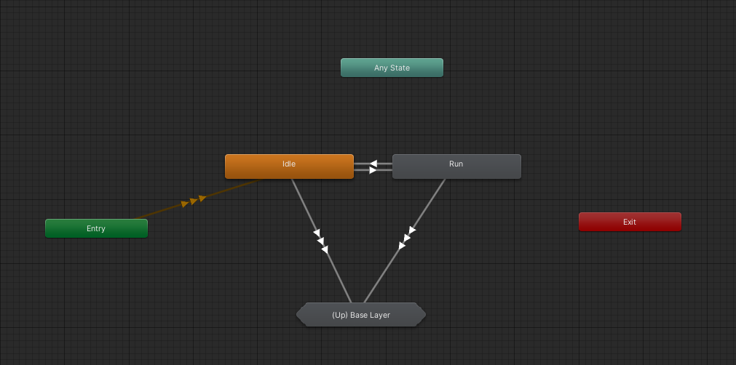

Fig. 3.11.2. Animation Controller for player character with movement sub-state



Fig. 3.11.2. Model being moved by animation controller

## Generating VAT for each animation

When I began creating VAT from the mixamo animations, I ran into a problem where the animation sampling was stuck on the first frame of the animation or was not updating the vertex positions over the course of the animation. After much investigation and confusion, it turned out to be a setting in the Humanoid Avatar, “Translate DoF” which needs to be true. This setting prevents the bone transforms from translating, only rotating throughout an animation. Which I believe may have prevented the vertex positions of the baked mesh from updating for some reason.

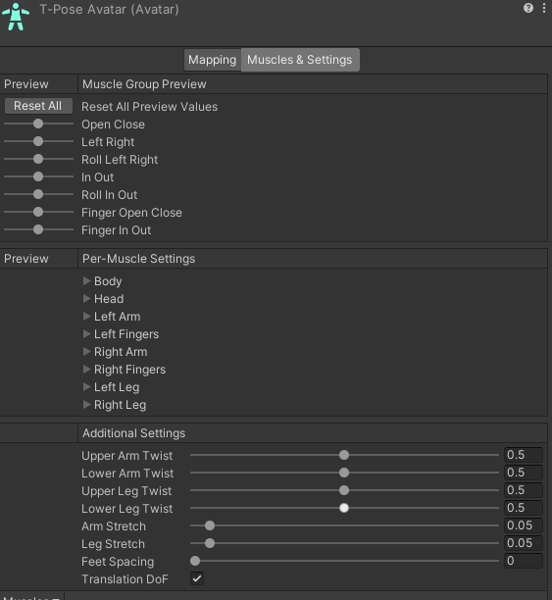

Fig. 3.11.3. Reading vertices of a Humanoid Avatar controlled model requires Translation DoF to be enabled

One final problem I ran into during the VAT creation process was that during the landing, the VAT was above the ground whereas the with the animation I can make the root y-position be based on the foot position. However, since the foot position method is determined during runtime on the cpu, I decided to apply a y-offset of -0.9f to the VAT position as the default animation was landing higher than the animated model.

## Syncing the VAT animations to the Animator

I first tried to sync things up using calls in the movement script; however I found it was just simpler to give each animation an event at the start to make the VFX system transition to the appropriate VAT. The only limitation with this method is that the function you wish to call must be in a script attached to the animator game object.

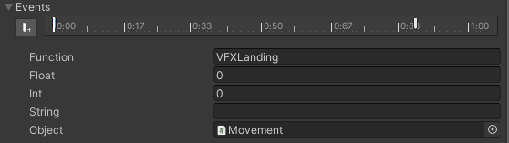

Fig. 3.11.4. Example of Animation Event to synchronise VFX transition with Animator Controller state transitions



Fig. 3.11.5. Successful synchronisation between VFX system and Animator controller

While the result is not perfect, it is adequate for my purposes moving forward. Some of the inconsistencies may be from CPU -> GPU delay or the timing of the one shot animations starting, or the animations that had to use root transform settings that were not “Original”. That said, the discrepancies are small and will not affect the overall visuals.

## Finetuning the Colliders

The final part of this player character is to fine-tune the colliders of the skeleton to align with the visuals. To achieve this, I attached one or more sphere colliders to each bone child object of the armature and set the layer of the children bones to “ParticleCollider” that I set to not interact with the ground. I still use the original capsule collider for general environmental collision however.

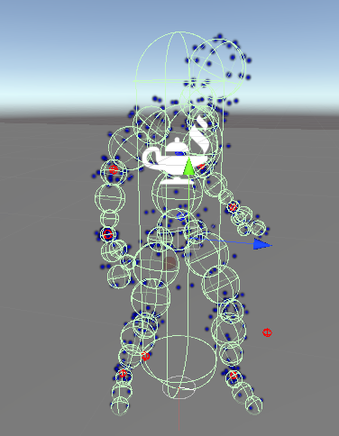

Fig. 3.11.5. Sphere colliders attached to the armature for finer collision detection

In my research before starting this, I read that OnParticleCollision would only apply to the colliders attached to the gameobject and would not extend to the colliders of the children gameobjects. After I implemented a new method of passing back the information to a CollisionCollector script; I found out that was no longer the case and in fact OnParticleCollision() is called on the most root gameobject that contains a collider; which meant that I did not have to change my original script at all and take advantage of the more complex collider model. It should be noted that this still worked even though the parent gameobject was on the Ground layer and the children were on the ParticleCollider layer.

The only downside to this revelation is that now I am unsure of how to disable the collider that is hit given that the message is passed to the parent and does not store which collider it hit.

**Update**

Turns out in Unity, when a child component has colliders attached to it, but no rigidbody, then Unity will turn all colliders into a composite collider to the root gameobject collider. Therefore, if I give each child object a kinematic rigidbody, then I can use my new method to isolate the individual gameobject that was hit. This however does not allow for me to isolate the collider as some gameobjects have multiple colliders.

**Update 2**

Turns out I can access the directly hit component via the particle collision events Collider component. This means that I do not need to use the individual system as I can access each collider in the composite collider when they are hit without the additional complexity.

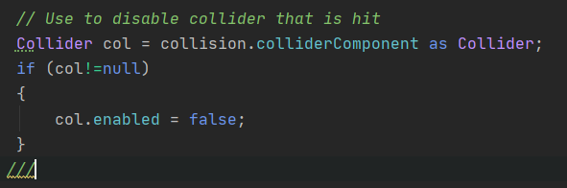

Fig. 3.11.6. Accessing the colliders being hit during a collision event directly

# Final Result



Fig. 3.11.7. Final player character

# Potential future Improvements

* Turn off colliders on the hit to allow for particles to go through gaps?
* Make the player out of more particles to remove excessive gaps
  + A subsystem that makes particles that move between vertices
  + A subsystem that leaves a trail of particles behind when moving
* Make particles dimmer on hit to represent health
  + Alpha = 0 for no health on particles
* Make player colliders affect surrounding particle objects like the ground
  + Other system light up when stepped on?
    - Maybe leave glowing footprints?
    - Leave ripple in other system?

# Final Product



Additional flair added with a floor particle system that responds to the distance from the feet of the player and when as particles move from being hit they leave spawn smaller particles.